This user guide section is meant to provide information on the Signatures Required:

Required Signature Action

### Required Signature Action

This action will allow the customer to view the information entered by the worker so that the customer can navigate through a series of pages where they can review/print the document, verify the information is correct, agree with the terms, and submit the transaction. Upon agreement of the terms, MyBCW will generate and append a standard signature template, with the signature, to the original document uploaded by the worker and reviewed by the customer. This process will generate a new complete document with the original document, including the customer’s electronic signature which is the agreement with the terms.

|  |  |
| --- | --- |
|  | The Case Action Solution provides Counties a simplified design to meet their dynamic needs. This solution needed to provide Counties with the flexibility to create actions to send or request information from the client. This included the ability to attach CalWIN correspondence and uploaded documents. It is recommended Counties involve their Policy and Procedures staff/departments when implementing the Action solution. This will ensure standards are established for workers when creating customer related actions. |

The worker will need to search for the case. Enter the Case Number and Search. Then select Add button.

|  |
| --- |
|  |

To start any action, the worker will enter the type of action needed for the client in the Action Type location. Enter the required information for this action, select “Signature Needed”, and Save.

|  |
| --- |
|  |

Once the action is been saved, the Provided Documents Tab and Queue Email Button are enabled. This unlocks the process of attaching documents to the action

|  |
| --- |
|  |

The Provided Documents Tab on the New Maintain Case Actions allows the worker to upload a file from their machine.  The upload option leverages a web control, which displays a little different in each browser.  Chrome will display “Choose File”, where Internet Explorer (IE) will use “Browse” button.

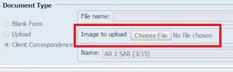

cid:image002.png@01D1962E.50C2A2D0

Signature Action will require a document to be added with a signature based Purpose (field) selected.

|  |  |
| --- | --- |
|  | Only one row can be added at a time. When the Add button is selected it will become disabled until the row is saved (Save Button). |

The following provide the steps to attach signature related documents.

#### Purpose: Rights and Responsibilities

Not all document signatures will require a rights and responsibilities to be attached. However, if one is needed then the Rights & Responsibilities (R&R) Purpose is available. When selected the R&R document will display in MyBCW for the customer to acknowledge prior to the actual signature page.

Enter the information in the required fields, including Purpose of ‘Rights & Responsibilities’, select a document to attach, and save. The Document Description field will be disabled for Rights & Responsibilities and Signature Purposes.

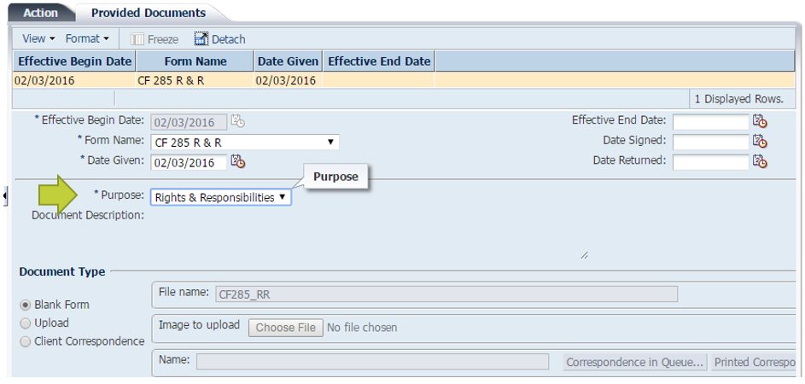

Additional documents may be added, however only one Purpose of ‘Rights & Responsibilities’ can be active (effective begin date) at a time. **If a mistake is made, then end date or delete the old record**.

Once the Action is saved the worker can select the Queue Email button to notify the customer or utilize another form of communication.

#### Purpose: Signature

A signature based Purpose is required for a signature Action to be completed in MyBCW. CalWIN provides a Signature Single or Signature Both, which will require two signature to be entering in MyBCW (ex – two parent household).

Enter the information in the required fields, including a signature Purpose, select a document to attach, and save. The Document Description field will be disabled for the Signature Purposes.

In this example a Client Correspondence item will be selected for a signature. The user will need to select the Client Correspondence Document Type Radio button and select the appropriate Correspondence button. In this example the Printed Correspondence Button is selected.

|  |  |
| --- | --- |
|  | When Correspondence in Queue option is selected the customer will not be able to access the Correspondence in MyBCW until the case action has been granted in batch. If the user tries to access an Action with a Queue Correspondence they will receive a message the action is not ready and to try back the next business day. |

|  |
| --- |
|  |

Selecting either Correspondence button will navigate the user to the appropriate search page, where the user can find and select the required document and choose the Select button. This will return the user to the Provided Documents tab with the correspondence fields populated.

|  |
| --- |
|  |

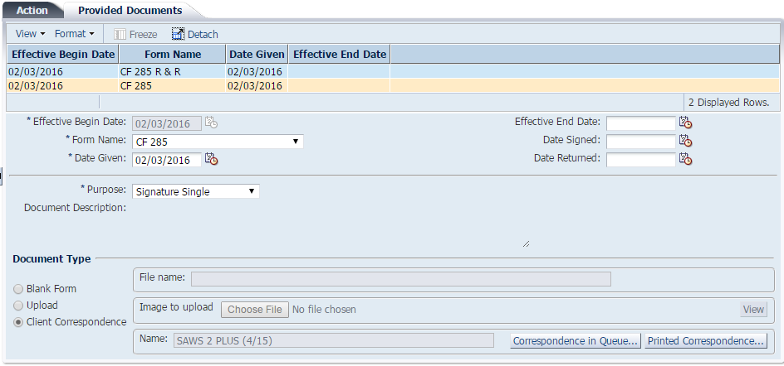

Additional documents may be added, however only one signature based Purpose can be active (effective begin date) at a time. If a mistake is made, then end date or delete the old record.

Once the Action is saved the worker can select the Queue Email button to notify the customer or utilize another form of communication.

When the customer signs into their MyBCW account, the Overview page will provide an alert to the number of open actions on their Case(s). If the Case does not have any actions, then this area will not display. Selecting the link will navigate to the Action Needed Page.

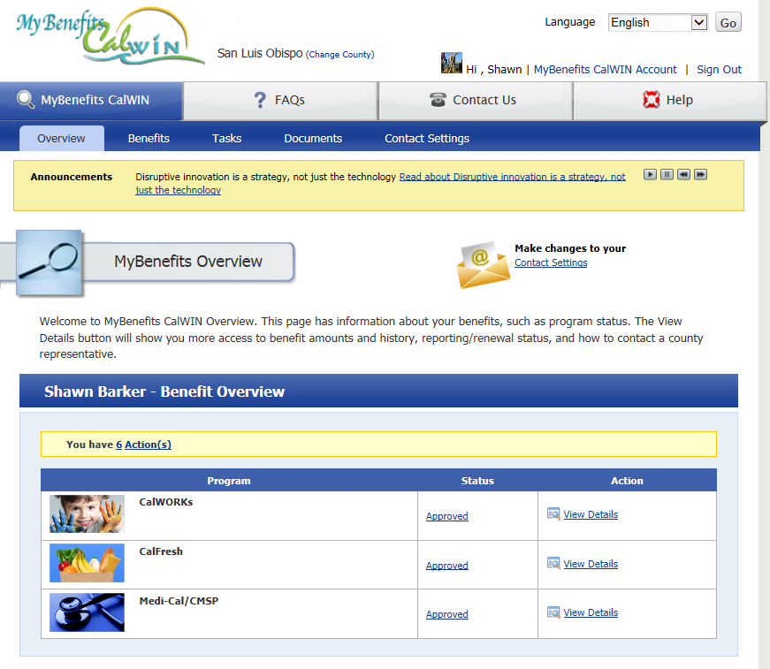

Selecting the link will navigate to the Action Needed Page. On the Action Detail Page only documents with a Purpose of Review will display on the right hand side (e.g. Documents to Review). Actions with a more recent due date will be displayed at the top. If an action did not have any Review documents, the Review pane will not be displayed. The Rights & Responsibilities (when added) and Signature documents will display as the client navigates through the action.

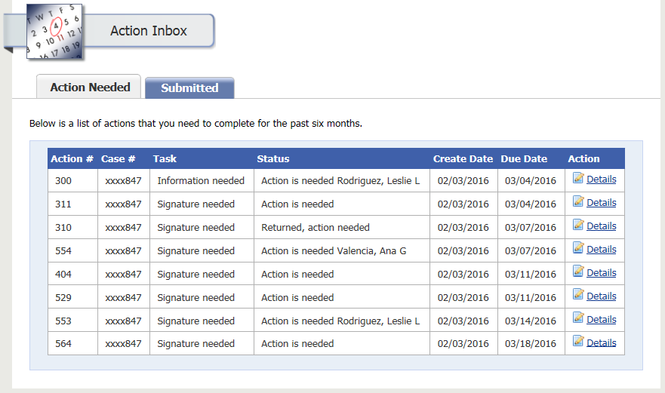

The customer will select the Start (or Continue) button to navigate through the steps to complete the online signature.

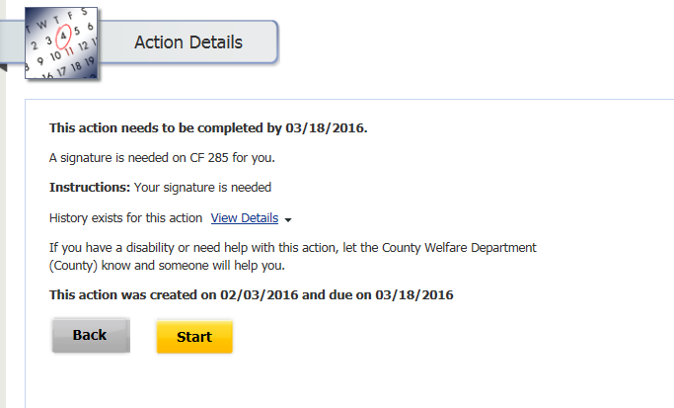

When a Rights & Responsibilities is associated to a signature action the following page will display. Otherwise this page is bypassed. The customer has the option to review and print a copy for their own records. The user will need to check the box to proceed to the next page.

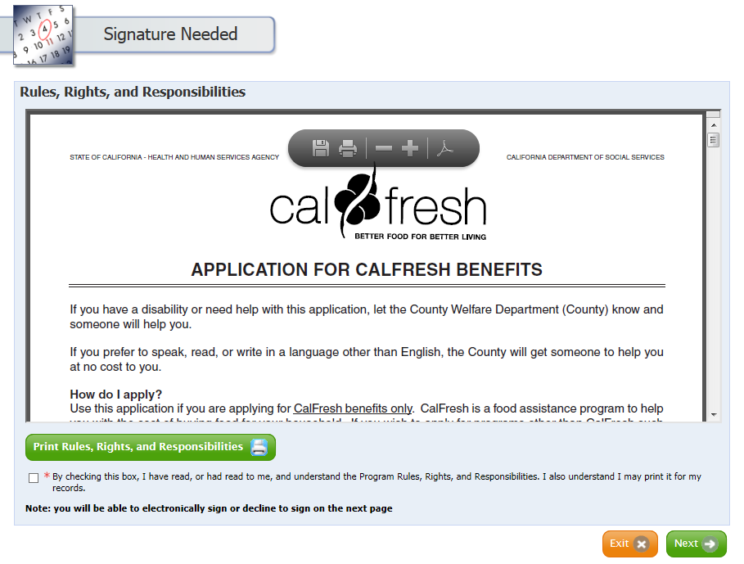

The following is the signature page, which will display the document selected by the worker in CalWIN.

|  |
| --- |
|  |

The customer has the opportunity to review the document and choose how to proceed by agreeing to the terms, not agreeing, or declining to sign online. The following provides a sample of the available options.

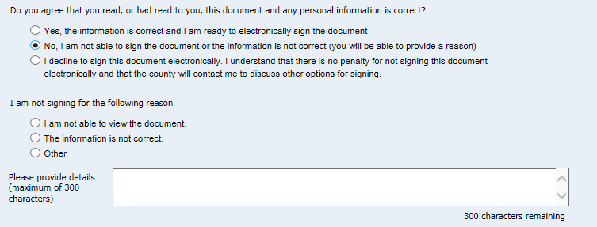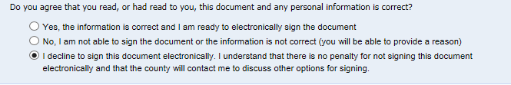

Upon making a selection the customer will be required to complete the mandatory fields and select the Next button. In this example, the customer selected they agree to the terms and completed the e-signature fields.

The Signature Review Page will display when a customer agrees to sign the form. The page will show the original signature document with an addition ‘signature’ page appended to the end with their answers from the previous pages. The customer will have an option to upload any additional documents before submitting their transaction.

|  |
| --- |
|  |

The Case Attachment displays the requested documents from the clients. The customer can attach additional forms which leverages existing MyBCW upload documents pages. An upload button is provided as a link to upload the requested documents from the client.

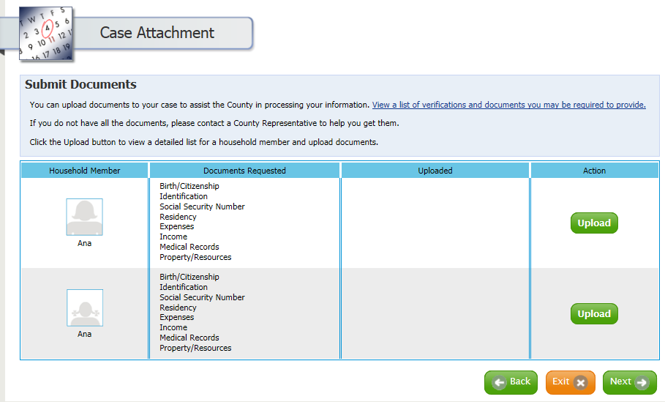

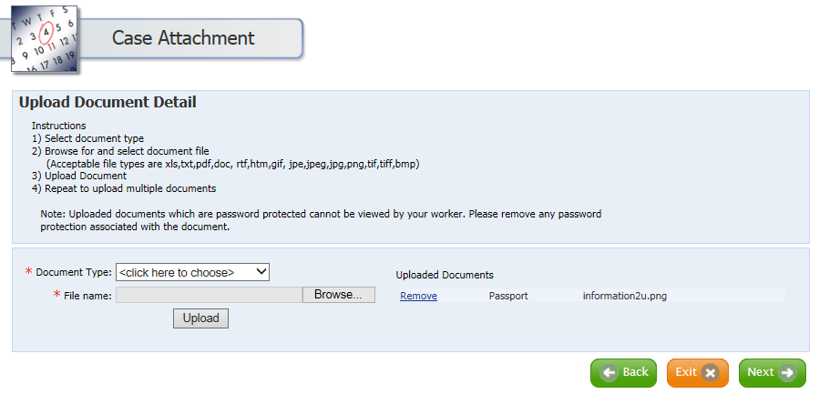

Once completed the customer will navigate to the Thank you page, where a confirmation can be printed, saved, or sent to the client via email.

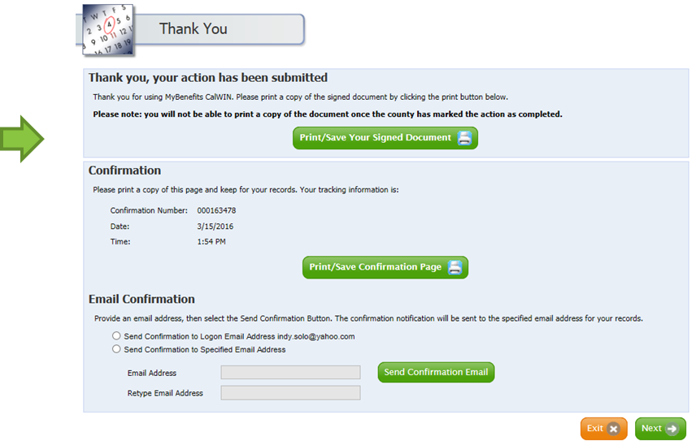

As with other BCW transactions, a record will display in the Search for Received Documents Page. By selecting the ‘All Documents…’ button, the user can view the documents on the Imaged Document list page submitted by the customer from MyBCW. Actions will have a ‘Case Action’ type and the Action # column will be populated. The user has the option to select an Action row and select the ‘Details…” button to navigate directory to the action (Maintain Case Actions page).

|  |
| --- |
|  |

By selecting the ‘Received Documents…’ button the user can view the documents on the Imaged Document list page which shows the signed signature page submitted by the customer from MyBCW.

|  |
| --- |
|  |

In this example the worker has confirmed the customer completed the action. The worker will update the Action Status to Closed and save.

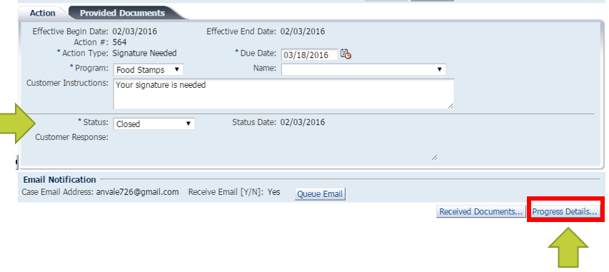

After the Progress Details button is selected, the Display Progress Details Summary page will be displayed and a worker can review a history of the Actions.

|  |
| --- |
|  |

Once an action is closed the customer will also have similar options with MyBCW. By selecting the History link (View more details) the customer will have a view similar to the Progress Details in CalWIN.

The customer will also have the ability to view the documents that were submitted with this action.

|  |  |
| --- | --- |
|  | Once a Signature Action is closed the user will not be able view the actual document(s) submitted due to the secure nature of the action. |

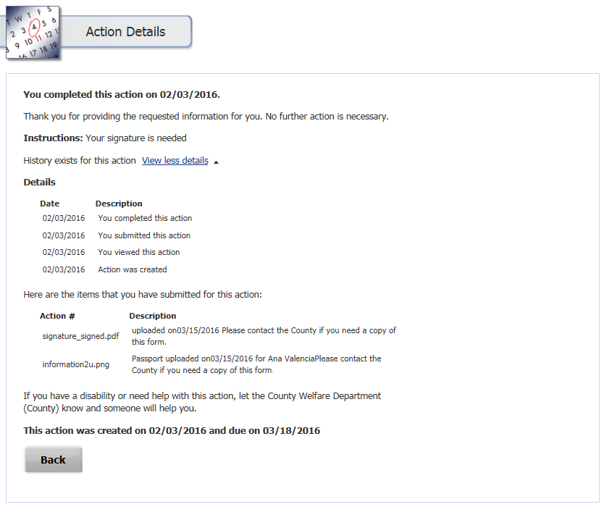

## Signature Rejected

A customer rejecting a signature Action is simulated below. This action does not include a Rights & Responsibilities document.

On the Signature Page, the customer selects “No, I am not able to sign…” for electronic signature. This provides a reason why the action is rejected. The customer then selects the Next button.

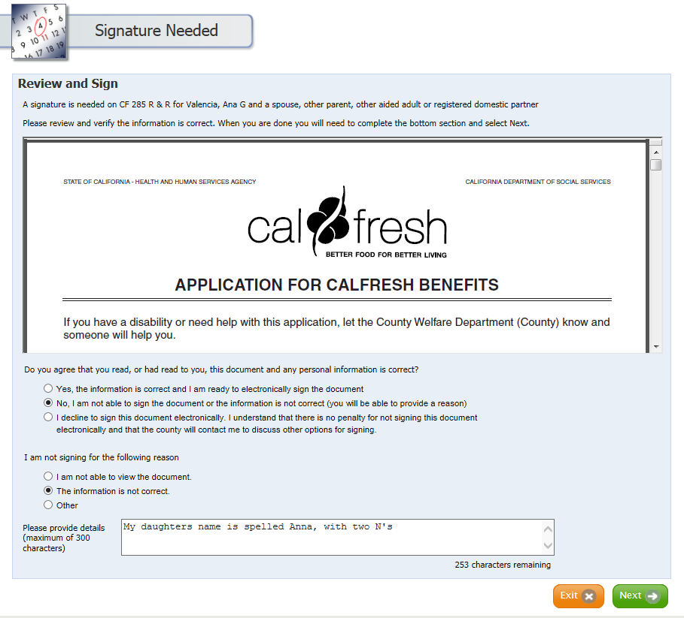

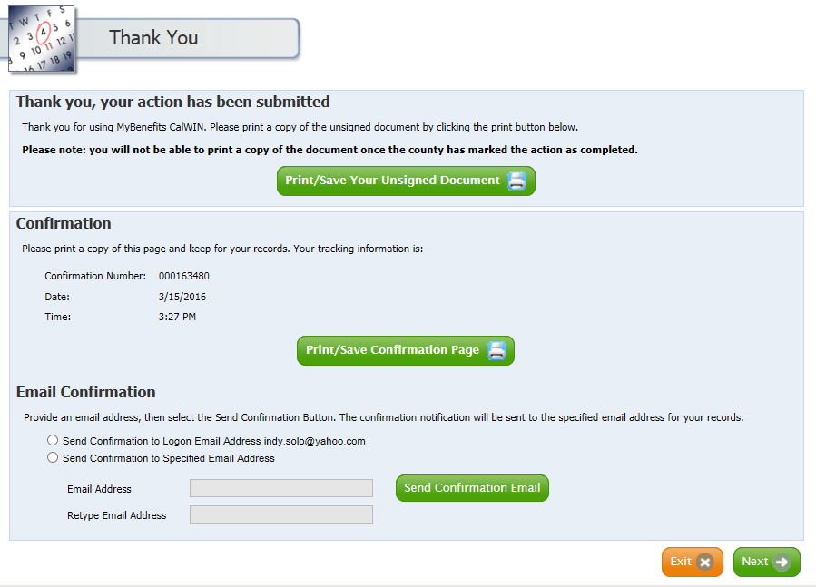The Signature Review Page is only displayed when the customer agrees to electronically sign the document. Since the customer did not agree, the system will bypass the Review page and will navigate directly to the Thank you page, where a confirmation can be printed, saved, or sent to the client via email.

After selecting the Print/Save, the Unsigned Document button will display the original signature document with an addition ‘signature’ page appended to the end of the document. The customer’s answers will be displayed from the previous pages, including the reasons why the customer did not sign the form.

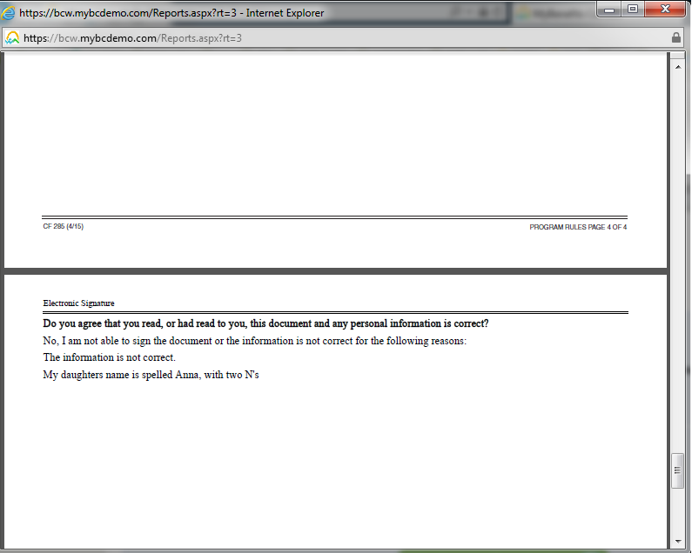

Within CalWIN, the Worker will be able to view the customer’s reason for the rejection in the Customer Response Field on the Maintain Case Action page.

|  |
| --- |
|  |

|  |
| --- |
|  |

In addition the worker will be able to select the Received Documents button to view the documents generated in MyBCW.

If a new signature document needs to be attached, the worker will need to end date or delete the existing signature record before adding a new row.

|  |
| --- |
|  |

Once the Action is saved the worker can select the Queue Email button to notify the customer or utilize another form of communication.

The customer will return to MyBCW and complete and submit the action (as outlined in the PURPOSE: SIGNATURE section.

## Signature Wrap up: create a new action

From the Main Navigation, select Intake and Case Maintenance > Data Collection > Perform Data Collection Wrap-up. Enter Case Number and click on Open.

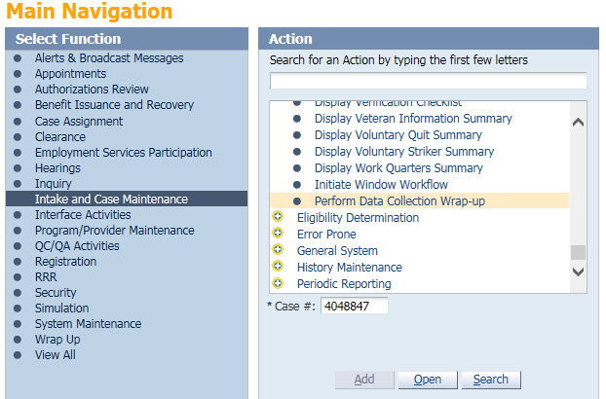

Select Program and Assigned User. Click on Initiate SOF (Statement of Fact) Action button

|  |
| --- |
|  |

CalWIN will generate a Statement Of Facts, however it will not be sent to printer. It will be added to the Correspondence Print History on the case.

|  |
| --- |
|  |

If there are one or more open signature Actions (for the same program) on the case, a message box pops up asking if the user wants to add the SOF to a new action or add this SOF to an existing action.

|  |
| --- |
|  |

When ‘Yes’ is selected, the system will navigate the User to the Maintain Case Actions page to create a new action. The system will automatically pre-populate a few of the fields and the user will be responsible for the remaining details (e.g. Due Date). Once the action has been saved, the Provided Documents Tab and Queue Email Button are enabled. This unlocks the process of attaching documents to the case.

|  |
| --- |
|  |

When the Provided Documents tab is selected the system will continue to pre-populate additional details from the Wrap Up page. The SOF and R&R documents will already be added. The worker is responsible to validate the information in each row and complete the necessary information.

Once the Action is saved the worker can select the Queue Email button to notify the customer or utilize another form of communication

|  |
| --- |
|  |

The Provided Documents Tab on the New Maintain Case Actions allows the worker to upload a file from their machine.  The upload option leverages a web control, which displays a little different in each browser.  Chrome will display “Choose File”, where Internet Explorer (IE) will use “Browse” button.



