Electronic Signature (e-Sign)
Introduction
Check to Sign Signature Method
CW/CF e-Sign Signature Method
Requesting an Electronic Signature Using the CW/CF e-Sign Signature Method
Signature History
Electronic Signature Document Detail
Forms

Purpose
The purpose of this job aid is to provide information to Users regarding the Electronic Signature (e-Sign) options for forms in the C-IV System.

Introduction
Electronic Signature is a method of capturing a Customer’s signature or intent through electronic options rather than signing a physical piece of paper. The application process allows the Customer to physically sign or complete an electronic signature for specific documents. Users can select the electronic signature options on the Electronic Signature page.
The Electronic Signature page allows Users to request a signature from up to two Customers whose intent is to electronically sign a document. On this page, Users select one of two methods: Check to Sign or CW/CF e-Sign. The Electronic Signature page is covered more later in this job aid.
The CW/CF e-Sign has three signature capture types to choose from:
      - E-mail
      - Text
      - Interactive Voice Response (IVR)
Note: It is recommended that the User select CW/CF e-Sign to capture a valid signature if a form is for CalFresh only or multiple programs including CalFresh. The Check to Sign option only applies to Medi-Cal or CalWORKs forms.

Check to Sign Signature Method
The Check to Sign signature method allows the User to sign the document on behalf of the Customer(s). For this method of electronic signature, Users may sign a document for one or two Customers.
Note: The Check to Sign signature method may be used for Medi-Cal and CalWORKs forms. A list of all applicable forms and methods is available at the end of this job aid.
The Check to Sign signature method is selected on the Electronic Signature page, which is accessed from a document on the Distributed Documents Search page.
Follow one of these navigation paths to access the Distributed Documents Search page:
- Place the cursor over Eligibility, Empl. Services or Child Care in the Global navigation bar. Then, click Distributed Documents in the Local navigation bar.
- Place the cursor over Document Control in the Global navigation bar. Then, click Documents in the Local navigation bar.
Note: CalFresh regulations do not consider this signature method a valid electronic signature method. It is recommended Users not use this method when attempting to capture an electronic signature on CalFresh related forms or multi-program forms when a CalFresh program exists.

Starting Point
Follow these steps to use the Check to Sign signature method. The following steps assume you are in the context of a case and on the Distributed Documents Search page.
Step | Action
On the Distributed Document Search page:
- Click the Details button for the document the Customer wants to sign electronically.
On the Document Detail page:
- Click the eSign button.
On the Electronic Signature page:
- Select Check to Sign from the Signature Method drop-down box.
- Select the <Number> from the Number of Signatures drop-down box.
- Select the <Person’s Name> from the Person drop-down box. Completed this step for each signature if you selected 2 from the Number of Signatures drop-down box.
- Select the Check to Sign check box for each signature.
Note: By selecting this check box, you indicate that a signature is received and on file in C-IV for a Customer.
- Review all instructions on the page. Then, click the Save button.

Once you save the Electronic Signature page, the Electronic Signature Document Detail page displays.

CW/CF e-Sign Signature Method
The CW/CF e-Sign signature method allows the Customer to electronically sign documents using one of three signature capture types: E-mail, Text or IVR (Interactive Voice Response). All signature capture types require the Customer to take an action to complete the signature. This signature method is selected on the Electronic Signature page.

Signature Capture Type: E-mail
For the Signature Capture Type of E-mail, the Value column on the Electronic Signature page displays the e-mail address entered for that person on the Contact Detail page, which is the e-mail address that the C-IV System uses to send the signature request. This is not an editable field. If the e-mail address is not correct, the User needs to edit the e-mail address on the Contact Detail page before saving the signature request.
After the User saves the Electronic Signature page for an E-mail signature capture type, the C-IV System sends an e-mail to the displayed e-mail address. At this time, the Customer is responsible for completing the signature request.
Customers receive an e-mail with an encrypted hyperlink to C4Yourself. The e-mail contains instructions on completing the signature request. Customers do NOT have to have a C4Yourself account to complete a signature request using this method. Customers are prompted to enter their e-mail address and date of birth to complete the process. When Customers do not complete the signature request, a reminder e-mail is sent one day following the initial e-mail.
Note: When more than one Customer share one e-mail address, the e-mail sent does NOT distinguish to whom the e-mail request is intended. It is recommended that the Worker explain this to the Customers and perhaps suggest one Customer receives the e-mail request and the other Customer receives the text message request.
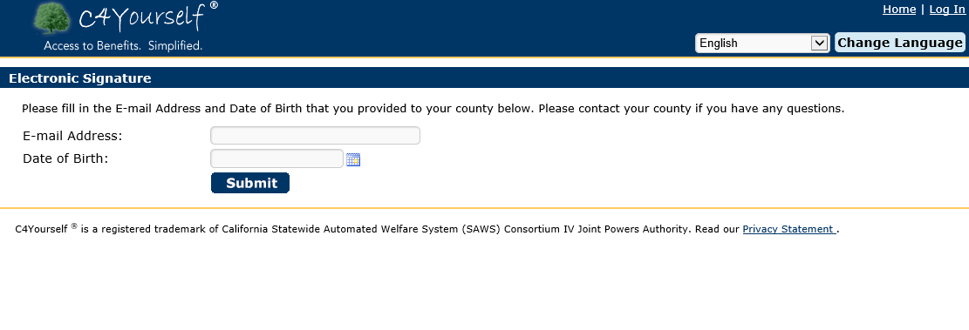
Note: When Customers do not enter the correct information after 10 attempts, the C-IV System locks their signature request until the next day (after midnight). At that time, Customers may attempt to complete the signature again.
E-mails are only sent in English or Spanish. However, C4Yourself is available in all threshold languages.

Signature Capture Type: Text
For the Signature Capture Type of Text, the Value column on the Electronic Signature page displays the phone type and phone number entered for that person on the Contact Detail page, which is the phone number to which the C-IV System sends the signature request. If the phone number is not correct, the User needs to edit the phone number on the Contact Detail page before saving the signature request.
After the User saves the Electronic Signature page for a Text signature capture type, the C-IV System sends a text message to the displayed phone number. At this time, the Customer is responsible for completing the signature request.
The User should confirm with the Customer the phone number is text capable and advise the Customer that standard data rates may apply.
Customers receive a text message in real-time with a code and instructions to complete the signature request. Customers need to reply to the text message using the code provided to complete the process. When Customers do not complete the signature request using this method, a reminder text message is sent one day following the initial text message.
Text Messages are only available in English and Spanish.

Signature Capture Type: Phone - Interactive Voice Response IVR
For the Signature Capture Type of Phone – Interactive Voice Response IVR, the Value column on the Electronic Signature page does not display a value until the User saves the page. This Signature Capture Type requires the Customer to initiate the signature process using a toll-free phone number.
After the User saves the Electronic Signature page for an IVR signature capture type, the Value column displays a capture code. The User provides this code to the Customer along with the toll-free IVR phone number. The Customer is unable to complete the signature request without this information.
When Customers call the toll-free IVR phone number, the IVR system prompts them to enter their date of birth and capture code to complete the signature request.
Note: There are no IVR outbound reminder calls for electronic signature requests using the IVR signature capture type.
The IVR e-Signatures are only available in English or Spanish.

Requesting an Electronic Signature Using the CW/CF e-Sign Signature Method
The CW/CF e-Sign signature method, which is selected on the Electronic Signature page, may be used for one or two signatures.
Note: It is recommended that Users select this method for all CalFresh forms and forms used for multiple programs that include CalFresh.
This page is accessed from a document on the Distributed Documents Search Page:
Follow one of these navigation paths to access the Distributed Documents Search page:
- Place the cursor over Eligibility, Empl. Services or Child Care in the Global navigation bar. Then, click Distributed Documents in the Local navigation bar.
- Place the cursor over Document Control in the Global navigation bar. Then, click Documents in the Local navigation bar.

Starting Point
Follow these steps to use the CW/CF e-Sign signature method. The following steps assume you are in the context of a case and on the Distributed Documents Search page.
Step | Action
On the Distributed Document Search page:
- Click the Details button for the document the Customer wants to sign electronically.
On the Document Detail page:
- Click the eSign button.
On the Electronic Signature page:
- Select CW/CF e-Sign from the Signature Method drop-down box.
- Select the <Number> from the Number of Signatures drop-down box.
- Select the <Person’s Name> from the Person drop-down box. Complete this step for each signature if you selected 2 from the Number of Signatures drop-down box.
- Select the <Signature Capture Type> from the Signature Capture Type drop-down box.
- Click the Save button.

Once you save the page, the signature request is sent to the Customer. The document is signed when signatures for all persons are received. The Status column displays the signature status for the corresponding person. The following statuses may display in the Status column:
- Sent – An active signature request was sent to the Customer.
- Sending Error – The signature request was not received by the Customer when using the E-mail or Text signature capture methods.
- Expired – the signature request has expired.
Note: All signature requests expired three (3) days from the date sent. Users can resend the signature request if applicable.
- Received – The signature request was completed by the Customer.

Users may resend the signature request by clicking the Resend button on the Electronic Signature page. The User may change the Signature Capture Type prior to resending the signature request if applicable.
Users may cancel or remove a signature request from any person with a signature status of Sent, Expired or Received. To remove a request, select the Remove check box for the person and click the Save button.
Note: The signature history displays for persons that were removed.

Signature History
The Signature History expandable section displays on the Electronic Signature page once the User saves the page if CW/CF e-Sign is the selected Signature Method. A separate Signature History section displays for each person included in the initial signature request, including signature requests that have been removed. The following statuses may display in the Signature History:
- Sent – A signature request was sent to the Customer.
- Sending Error – The e-mail or text was not received by the Customer.
- Expired – The signature request has expired.
- Incorrect Response – The signature request was received, but failed validation.
- Received – The signature request was received and validated.
- Canceled – the Customer’s signature request was canceled by the User.
- Already Received – The Customer’s signature has already been received using a different Signature Capture Type.
The C-IV System creates a journal entry, task, and Customer contact history record when the status updates.
A journal entry is created for the following:
- Signature Request Sent
- Signature Request Expired
- Signature Request Completed/Received
- User Cancels Request
- Reminder Sent (E-mail or Text)
- Signature Request was Undeliverable to Customer.
The C-IV System creates a task for the following:
- Signature Request Expired
- Signature Request Completed/Received
- Signature Request was Undeliverable to Customer (E-mail or Text).
Note: Tasks are associated to the User who requested the electronic signature.
The C-IV System does NOT generate tasks until the county sets the automated action to active. See Job Aid: Task Management for more information on setting automated actions.
A Customer contact history record is created when the C-IV System sends an E-mail or Text signature request or reminder.

Electronic Signature Document Detail
The Electronic Signature Document Detail page displays the following information:
- The ID includes a prefix of ES if the signature was completed on the Electronic Signature page. Example: ER-1234
- The e-Sign Name column displays:
  - The name of the Customer who e-signed the document, or
  - The name of the User if the Electronic Signature was provided by the User.
- Signature History – This section displays history of the document’s signature requests.
  - A separate history section displays for each person included in the initial signature request.
  - The Date/Time column displays the date and time a signature action took place.
  - The Signature Capture Type used to send the signature request.
  - The Value used.
  - The Status of the signature request.
  - The Expiration Date of the signature request.

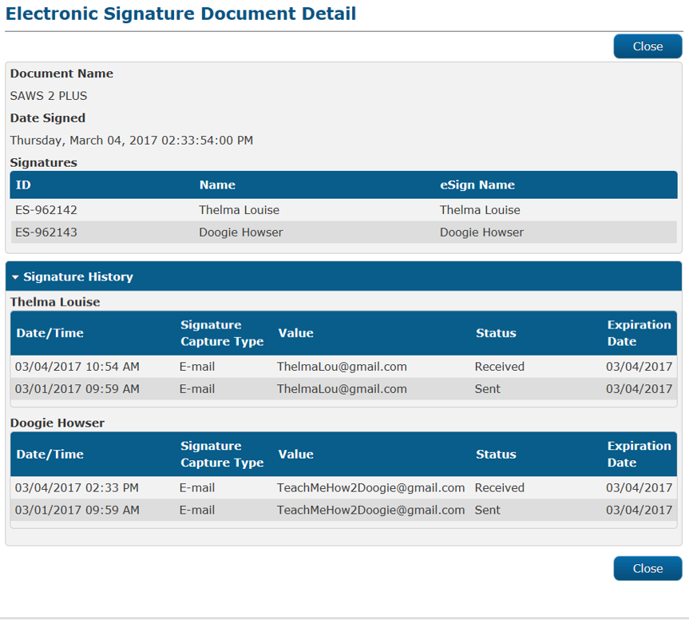

Forms
The below table lists the forms that Customers may e-Sign.
Form Number | Form Name | Check to Sign | CW/CF e-Sign
ABCD 47A | Disqualification Consent Agreement - CalWORKs | *
ABCDM 228 | Applicants Authorization For Release of Information | * | *
CD 7617 | Child Care NOA | *
CD9600 | Child Care Application | *
CD 9600A | Child Care Data Collection Privacy Notice and Consent Form | *
CF 306 CIV | Demand Letter for Over issuance |  | *
CF 37 | Recertification for CalFresh Benefits |  | *
CF 478 | Disqualification Consent Agreement-CalFresh |  | *
CMSP 1178 | Profit and Loss Statement | *
CMSP 202 | Med Impact Pharmacy Immediate Need | *
CMSP 215 | CMSP Supplemental Application | *
CMSP 609 | County Request for CMSP Claims Detail | *
CW 2.1NA | Notice and Agreement for Child, Spousal and Medical Support | *
CW 2.1Q | Support Questionnaire | *
CW2.1Q/2.1NA | Support Questionnaire / Notice and Agreement for Child, Spousal and Medical Support | *
CW 2186A | CalWORKs Time Limit Exemption Request | *
CW 306 CIV | Demand Letter for Overpayment | *
CW 5 | Veterans Benefits Verification and Referral | *
CW 61 | Medical Report | *
CW 71 | Statement of Cash Aid Applicant / Recipient and Unrelated Adult | *
CW 81 | Lien Agreement | *
DFA 874 | Statewide Intercounty Lost Warrant Replacement Affidavit | *
DFA 479 | Administration Disqualification Hearing Waiver CalWORKs / CalFresh | * | *
FIN 100 CIV | Agreement to Reimburse Note | *
FIN 115 CIV | Valuable Issuance Acknowledgement | *
HCR RFTHI | Request for Tax Household Information (RFTHI) | *
HEAR 302 CIV | Withdrawal of Hearing Request | *
INF 102 CIV | Be Vu Informing Notice |  | *
IVR 100 | IVR Notification Consent Letter | * | *
MC 05 | Military Verification and Referral Form | *
MC 13 | Statement of Citizenship, Alienage, and Immigration Status | *
MC 176 TMC | Transitional Medi-Cal (TMC) Quarterly Status Report | *
MC 194 | Social Security Administration Referral Notice | *
MC 200 | Voter Registration | *
MC 210 | Mail-In Application – MC 210 Medi-Cal Mail In Application | *
MC 210 PS | Property Supplement | *
MC 210 RV | Medi-Cal Annual Redetermination Form | *
MC 210 S-1 | Income In-Kind/Housing Verification | *
MC 219 | Rights and Responsibilities | *
MC 223 | Applicant’s Supplemental Statement of Facts for Medi-Cal | *
MC 262 | Redetermination for Medi-Cal Beneficiaries | *
MC 273 | Work Activity Report | *
MC 325 | Request For Transitional Medi-Cal (TMC) Or Four Month Continuing Medi-Cal | *
MC 61 | Medical Report | *
MC 1273 | Electronic Agreement | * | *
NA 301 CIV | Generic Cash Overpayment Informing / Demand NOA | *
NA 303 | Cash Property Overpayment Informing/Demand NOA | *
NA 304 | Collections Demand Letter | *
Plan 102 CIV | Progress and Attendance | *
Plan 105 CIV | Job Search | *
Plan 107 CIV | Action Plan | *
Plan 108 CIV | Employer Contact Verification | *
Plan 112 CIV | Care of Household Member Verification | *
SAR 7/SAR 2 | Semi-Annual Eligibility Status Report/Reporting Changes For Cash Aid and CalFresh | * | *
SAR 72 | Sponsor’s Semi-Annual Income and Resources Report | * | *
SAR 73 | Senior Parent’s Semi-Annual Income Report | * | *
SAWS 1 | Initial Application for CalFresh, Cash Aid, and/or Medi-Cal / Health Care Programs | * | *
SAWS 2 PLUS | Statement of Facts | * | *
SAWS 2A SAR | Rights, Responsibilities And Other Important Information |  | *
Temp 2201 | Cash Aid/CalFresh Electronic Benefit Transfer – EBT Request For A Designated Alternate Card Holder | * | *
Temp 2202 | Cash Aid / CalFresh Electronic Benefit Transfer – EBT Service Request | * | *
Temp 2203 | Request for Cash Aid Electronic Benefit Transfer – EBT Exemption | * | *
TEXT 100 | Text Notification Agreement | * | *
VER 101 CIV | Address Change / Housing Costs Form | * | *
VER 102 CIV | School Attendance Verification | * | *
VER 106 CIV | School Attendance and Expense Verification | * | *
VER 107 CIV | Employment and Income Information | * | *
VER 108 CIV | Release of Information – Financial Institution | * | *
WTW 1 | Welfare to Work Plan – Rights and Responsibilities | *
WTW 10 | Request for Welfare to Work Third-Party Assessment | *
WTW 12 | Welfare to Work / Cal-Learn Supportive Service Repayment Agreement | *
WTW 2 | Welfare to Work Plan – Activity Agreement | *
WTW 27 | Request for Good Cause Determination | *
WTW 29 | Plan to Meet Welfare to Work Rules and Get My Cash Aid Back | *
WTW 31 | Request to Meet Welfare to Work Rules to Get My Cash Aid Back | *
WTW 32 | Welfare to Work Compliance Plan | *

