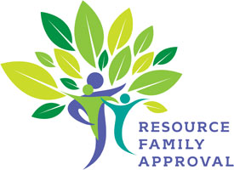
Out of County Complaint Investigation Notification
(To the Placing County)

DATE: _____________________________________________________
TO RFA PLACING COUNTY: ____________________________________
FROM RFA APPROVAL COUNTY: _______________________________
There has been a report received by the RFA Program in _______________ County regarding a Complaint Investigation on RF ______________________________, with whom you have a dependent child/children placed.
Date of RFA Approval:
Date Complaint Investigation Referral received:
Date 10 Day Visit Due:
Notes(Include name and contact information for investigating party. If CCL, please so indicate):
Investigation Information:
Pending - Estimated Date of Completion
Finalized – Outcome: Substantiated Inconclusive Unfounded

Serious Incident: Yes No
Serious Complaint: Yes No
Date Serious Incident/Serious Complaint Reported to CDSS & State Liaison (If Applicable):

Notes:

Name Email Address

^{Phone Number}

