CALIFORNIA ADULT REPATRIATION INTAKE FORM
Repatriate Name: Date:
Who is embassy caseworker/social worker:
Can we talk to them:
*Please complete fields for which you have information.
If you do not have information, please leave the field blank*

Demographic Information:

Age: DOB: Country of destination: Language:

Gender: Check if a Veteran: ☐

Repatriation leaving (check one) ☐ voluntary ☐ involuntary

Is the repatriate a deportee? Visa Status:

Valid Identification: Any other form of identification?

Medical Information:

Medical history/diagnostic information (specify whether chronic) (any and all information is appreciated, with as much detail as possible):

Please specify if client has memory loss and to what extent (Please provide an example)?

Current medications:

Will they be arriving with meds and, if so, what is the dosage?

Any mobility/ambulation issues?

Devices needed (e.g. wheelchair, ambulance, glasses):

Mental Health Information:

Mental health history/diagnostic:

Client is acute/in crisis ☐

Details regarding current treatment plan:

Danger to self/others? Please be specific:

CA Adult Repatriation Intake Form 2020

Financial Status:

Does repatriate have SSI or other Income?

Does the repatriate have bank accounts outside the US and if so, does repatriate have access to these accounts?

Will repatriate have access to SSI or other income upon arrival?

Does the repatriate have Medi-cal and/or Medicare benefits in place?

Residency Information:

Residency status at time of repatriation?

Does the repatriate have an identified residence upon arrival?

From where is the repatriate being discharged or released?

☐ Shelter ☐ Hospital ☐ Facility ☐ Family home ☐ Prison ☐ Other

Was repatriate homeless prior to being identified as a repatriate?

Residency History/Affiliation with County/State upon arrival in the US? If so, what is the location?

Behaviorial Issues:

If a danger to self or others, please describe in more detail:

Does the repatriate have a history of violence and when was the most recent incidence of violence?

Does the repatriate have a conviction or if coming from prison, what was the criminal conviction?

Does the repatriate have any current substance abuse issue?

Drugs of choice? /ETOH use?

Repatriate Needs During Transport to CA County:

Would the repatriate benefit from an escort?

CA Adult Repatriation Intake Form 2020

Would the repatriate benefit from a nurse?

Does the repatriate have any hygiene issues?

Does the repatriate require any incontinence supplies?

Contact Information / Support System:

CA Contact information (please specify if local to County of repatriation):

Family members (name, phone, address and email)

Friends (name, phone, address and email)

How much luggage?

Does the repatriate have a cell phone? If so, cell number:

Optimal arrival is Mon-Thu during business hours otherwise repatriate may not be housed. Assessment will be made for the most appropriate housing in the County of repatriation. Note that housing may be limited.

CA Adult Repatriation Intake Form 2020
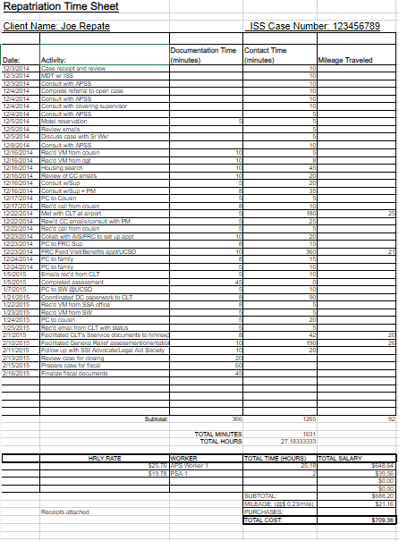

CA Adult Repatriation Intake Form 2020

