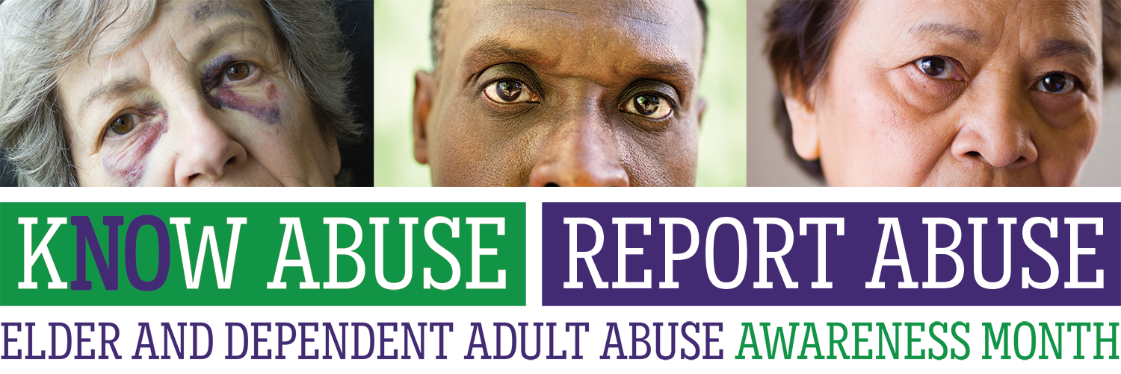

**CAMPAIGN TOOLKIT**

**Prepared for the California Association of Area Agencies on Aging Elder Justice Workgroup**

**Prepared by,**

Perry Communications Group

980 9th Street, Suite 410

Sacramento, CA 95814

Toolkit Materials Include:

|  |  |
| --- | --- |
| Item | Description |
| Know Abuse Report Abuse Campaign Logo | Please use this logo on your social media channels, in your newsletter mailings, and all other campaign documents. It can be combined with organizational logos as well. |
| Letterhead | This letterhead uses the logo and allows for space to insert local APS and Ombudsman reporting information. |
| Supporter Outreach Letter | This was sent earlier this year and is meant to be used to galvanize support for the campaign from local groups you work with on the ground. |
| Campaign Fact Sheet | This fact sheet can be used to explain the campaign to potential partners and directs questions to Derrell Kelch, Executive Director for the California Association of Area Agencies on Aging. |
| Elder & Dependent Adult Abuse Backgrounder | This backgrounder is perfect for fairs and other events where materials can be shared to raise awareness about abuse. |
| “Don’t Miss the Signs” Flyer | This informational flyer may also be used at fairs and events. It is meant to draw attention to the different indicators of abuse. Can be localized to include county-specific reporting information. |
| Newsletter Announcement | This announcement should be sent to your email distribution list to announce the campaign and ways folks can get involved from an organizational standpoint (or individually). It provides samples social media posts and its purpose is to officially launch the campaign with your mailing list. |
| Press Release | This sample press release should be used as a foundation document. Insert local events you plan to hold with elected officials and other relevant information to promote your June activities. |
| Public Service Announcements | There are multiple sample PSAs to choose from. Pick the one that best represents the message your organization wants to convey – feel free to edit. Reach out to your local radio stations as soon as possible to secure a spot. |
| Social Media Content Bank  (separate attachment) | This content bank should be used by AAAs and partner organizations to increase awareness of elder and dependent adult abuse, ensure people are equipped to recognize the signs of abuse and know who to contact if they suspect abuse. Use as many or as few posts from the bank as you see fit. Please post additional events, resources, etc. that your organization might have that is relevant to the campaign. |
| Legislative / Congressional Twitter Handles  (separate attachment) | Tweet at these key influencers to increase awareness. Make sure to place that period “.” in front of the Twitter handle. |

Campaign Logo

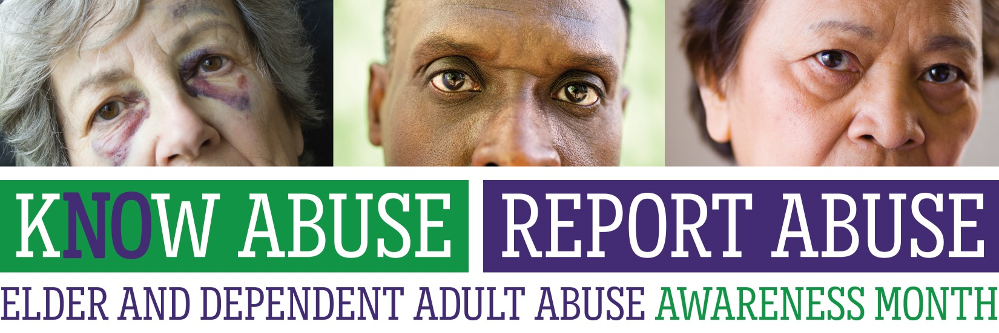

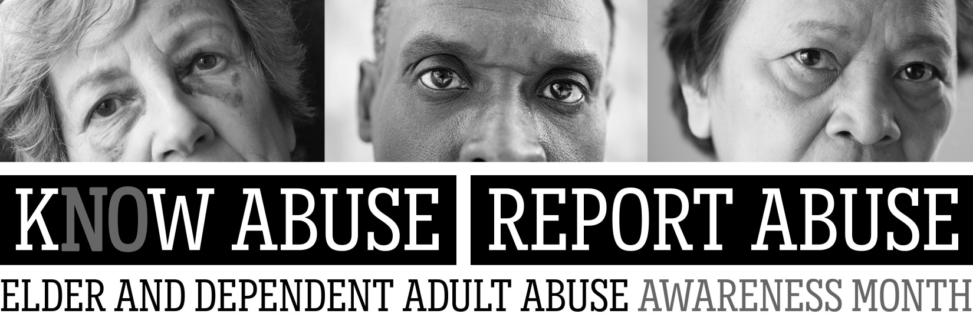



**REPORT TODAY: APS: INSERT PHONE NUMBER Ombudsman: INSERT PHONE NUMBER**

**Supporter Outreach Letter**

|  |  |
| --- | --- |
| WHAT | Request for Co-sponsorship/Support |
| PURPOSE | **To secure support from partner organizations/community leaders to increase the campaign’s reach** |
| NOTES | **Please tailor this request to your audience – depending on how well you know the recipient and how closely you’ve worked with the organization or community leader in the past.**  **Suggestions partners to send this letter to include:** MOU partners (financial and nonfinancial), program contractors (both APS and AAA), all cities within the local jurisdiction, community organizations and local elected officials. |

Dear <NAME>,

<Name of your org> is working with the California Association of Area Agencies on Aging (C4A) to bring awareness about elder and dependent adult abuse by launching a month-long education and resource campaign this June. The purpose of the campaign is to educate Californians about the different types of abuse (and how to recognize them) and how to report abuse to the appropriate local Adult Protective Services agency.

I’m reaching out to you today because you are a valuable partner and we need your support. By working together we can amplify the campaign here in <insert County> and ensure that older and dependent adults are given the respect and justice they deserve.

Partnering and support can take many forms. It could mean a joint press-release, co-hosting a community event, or sharing images and content on your social media accounts, just to name a few.

Can we count on <NAME OF ORG’S> support for our campaign?

**If YES**, please let us know what <NAME OF ORG’S> can commit to:

* Authoring a joint press-release
* Co-hosting a community event
* Sharing images and content on social media (we can provide drafted posts)
* Posting a link to our website on your website
* Posting campaign flyers or materials at your organization’s locations
* Other ________________________________________________________

*\*please tailor these options to best fit your AAA*

Lastly, if you are already working on a campaign please tell us about it so we can help with your efforts.

Thank you for your support and collaboration. If you have any questions, you may contact XXXXXXXX of my staff at XXXXXXXXX or via email at XXXXX.

NAME

TITLE

ORG



**What:** Elder and Dependent Adult Abuse Awareness Month

**When:** June 2016 to coincide with the World Elder Abuse Awareness Day -

June 15, 2016

**Why:** To educate Californians about different types of abuse, how to recognize them, and how and to whom to report abuse

**Contact:** C4A office at 916-443-2800. Speak to Derrell Kelch, C4A Executive Director

**Why we need you as a partner:**

Statewide Partner support is vital to the success of this campaign. We are excited that several key organizations have joined us in this important campaign. Partner organizations include: Administration for Community Living; Administration on Aging; California Commission on Aging; California Department of Social Services; California Elder Justice Coalition; California Long Term Care Ombudsman Association; Office of the State Long Term Care Ombudsman; County Welfare Directors Association of California; Elder Abuse Prevention and Ombudsman Services – WISE & Healthy Aging; and the California District Attorneys Association.

We are reaching out to you because your organization has been identified as a valuable partner and the campaign needs your support. Partnering and support can take many forms. It could mean a joint press-release, co-hosting a community event, or sharing images and/or content on your social media accounts. By working together, we can amplify the campaign throughout California and ensure that older and dependent adults are given the respect and justice they deserve. We look forward to you joining us in this effort.

**What we can provide to assist you:**

C4A has been working closely with Perry Communication, a Sacramento-based public relations firm, on developing campaign materials and an awareness toolkit. The toolkit includes: logo, tagline, outreach materials, public service announcements, website and social media content, press release, and newsletter templates. The toolkit materials will provide flexibility for each collaborative partner to tailor based on their own needs, planned events, activities, and support networks.



**REPORT TODAY: APS: INSERT PHONE NUMBER Ombudsman: INSERT PHONE NUMBER**

**HOW BIG OF AN ISSUE IS ELDER ABUSE IN CALIFORNIA?**

Here in California, Adult Protective Services (APS) receives as many as 10,000 reports of elder and dependent adult abuse per month, and reports are increasing.

That’s an estimated 120,000 cases of reported elder and dependent adult abuse PER YEAR in California. What makes this number even more alarming it that for every case of abuse that is reported, 4 cases go unreported. That’s an astounding 600,000 incidents that were never reported.

**THE STATE OF CALIFORNIA RECOGNIZES 6 TYPES OF ABUSE:**

1. **Self-Neglect –** Refusal or failure to provide himself/herself with adequate food, water, clothing, shelter, personal hygiene, medication (when indicated), and safety precaution.
2. **Physical Abuse** – The use of physical force that may result in bodily injury, physical pain, or impairment; or any physical injury to an adult caused by other than accidental means.
3. **Neglect by Others** – Failure to provide the basic care, or services necessary to maintain the health and safety of an adult: this failure can be active or passive.
4. **Sexual Abuse** – Sexual contact with a non-consenting adult or with an adult considered incapable of consenting to a sexual act.
5. **Financial Abuse**– The illegal or unethical exploitation and/or use of an elder’s funds, property, or other assets.
6. **Mental Abuse** – Verbal or emotional abuse includes threatening significant physical harm or threatening or causing significant emotional harm to an adult through the use of: Derogatory or inappropriate names, insults, verbal assaults, profanity, or ridicule; or harassment, coercion, threats, intimidation, humiliation, mental cruelty, or inappropriate sexual comments.

Abuse doesn’t happen in a vacuum. Often one type of abuse leads to another. Victims often suffer from multiple forms of abuse at the hands of their abusers. For example an older adult can be neglected by his or her family, whose only interest is control over the person’s financial assets.

**DON’T MISS THE SIGNS OF ABUSE**

|  |  |
| --- | --- |
| * Lack of basic amenities * Cluttered, filthy living environment * Unexplained or uncharacteristic changes in behavior * Unexplained sexually transmitted diseases | * Caregiver isolates elder * Unpaid bills, new credit cards and/or increased cash withdrawals * Harassment, coercion, intimidation, humiliation |

**KNOW ABUSE. REPORT ABUSE**

**How to report cases of abuse, whether it is on your own behalf or that of someone you know:**

|  |  |
| --- | --- |
| **Adult Protective Services** - Adult Protective Services (APS) responds to reports from individuals, concerned citizens, social service and health providers, and law enforcement representatives about developmental disabled adults, physically and mentally disabled adults, and the elderly who may be physically or financially abused, neglected, or exploited. Upon receipt of a referral, APS sends a social worker to make a home visit or contact the elder or dependent adult. **Your county APS hotline number: (XXX) XXX-XXXX.** | **California State Long-Term Care Ombudsman -** The Long-Term Care Ombudsman Program investigates elder abuse complaints in long-term care facilities and in residential care facilities for the elderly.The primary responsibility of the program is to investigate and endeavor to resolve complaints made by, or on behalf of, individual residents in these facilities, including nursing homes, residential care facilities for the elderly, and assisted living facilities. The goal of the program is to advocate for the rights of all residents in long term care facilities. **The State CRISISline number: 1-800-231-4024. Your local LTCOP number: (XXX) XXX-XXXX.** |

**INDIVIDUALS WHO ARE *MANDATED* TO REPORT ELDER ABUSE**

California law mandates that certain individuals report known or suspected incidences of elder or dependent adult abuse. Failure to do so is a crime.

* **WHO:** Persons who are responsible, in whole or part, for care or custody of an elder or dependent adult, whether or not that person receives compensation, are mandated reporters of elder and dependent adult abuse, including: administrators, supervisors, and any licensed staff of a public or private facility that provides care or services for older or dependent adults, or any elder or dependent adult care custodian, health practitioner, or employee of a county adult protective services agency or local law enforcement agency. In addition, all officers and employees of financial institutions are mandated reporters for suspected financial abuse of elders and dependent adults.
* **When:** By telephone immediately, or as soon as practically possible to the appropriate local agency: adult protective services, law enforcement, and/or long term care ombudsman; AND, by written report, California Department of Social Services Form “Report of Suspected Dependent Abuse/Elder Abuse” (SOC 341), sent within two working days.

**WHAT HAPPENS IF AN ALLEGED VICTIM DOES NOT WANT TO REPORT THE ABUSE?**

Adult victims of alleged abuse and neglect, unlike in Child Protective Service, have a right to decline services even if those services may help resolve an abusive situation. As is common in domestic violence cases, clients are often reluctant to report abuse; denying allegations, recanting previous statements, and making it difficult to provide services or to prosecute crimes. There are many reasons why one might not want to confirm abuse: fear of retaliation, embarrassment/shame, unwillingness to recognize what’s happening, protection of the perpetrator who is often a loved one or family member, belief abuse is deserved, not wanting the government involved in family matters, or fear of losing independence or institutionalization if abuse is discovered.

Regardless of whether or not you are a mandated reporter, it is important to report ALL suspected abuse. Even if the elder or dependent adult is reluctant or unwilling to disclose abuse, the investigating agency can provide the message that people care and help is available.

***Elder and Dependent Adult Abuse Awareness Month is a state-wide campaign with many partners, including:***

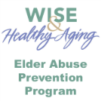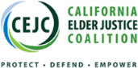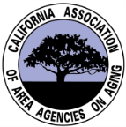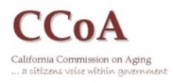  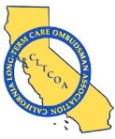

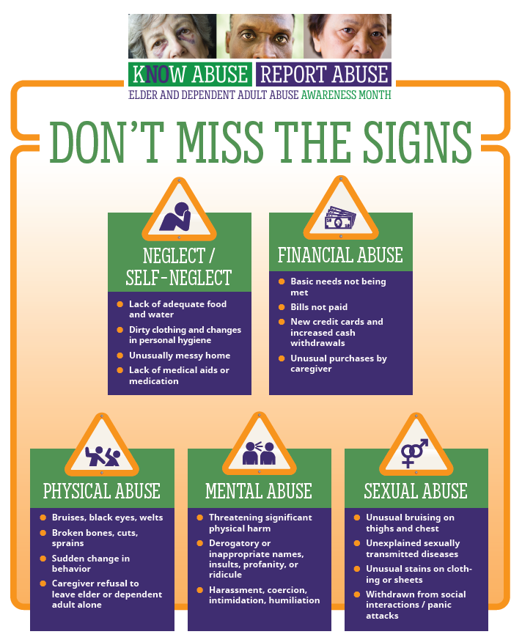

**REPORT TODAY:**

**APS: INSERT PHONE NUMBER Ombudsman: INSERT PHONE NUMBER**

**Elder and Dependent Adult Abuse Awareness Newsletter Content**

|  |  |
| --- | --- |
| WHAT | Draft newsletter content announcing Elder and Dependent Adult Abuse Awareness Month |
| PURPOSE | **For use by AAAs and partner organizations to announce the statewide campaign in the e-newsletter mailings.** |



The <ORG NAME/AAA> is excited to announce the launch of our Elder and Dependent Adult Abuse Awareness Month campaign this June. This is a first of its kind, statewide effort to increase awareness of elder and dependent adult abuse. Our collective hope is that increased awareness will result in increased reporting of suspected abuse, not only in the month of June, but for years to come.

Leading the campaign efforts is the California Association of Area Agencies on Aging’s Elder Justice Workgroup. They are working with Perry Communications Group, a Sacramento-based firm and with key partners in California including the California Commission on Aging, Administration on Aging, California Elder Justice Coalition, the California State Department of Social Services, the California Long-Term Care Ombudsman Program, the California Long-Term Care Ombudsman Association, California District Attorneys Association, County Welfare Directors Association of California, and WISE & Healthy Aging to create a campaign toolkit that can be used by each local area agency on aging and other partner organizations. The idea is to work more collaboratively on our shared goals and to create a message that is echoed throughout the state. The purpose isn’t to take away from the work and projects already planned locally, but to further supplement the existing outreach activities by creating an over-arching statewide narrative.

To capture the goals of the campaign, we have selected the following slogan and hashtags:

K**NO**W ABUSE. REPORT ABUSE.

#kNOwAbuseReportAbuse

#StopElderAbuse

We urge all partners to use this logo and slogan on the materials you create for your planned June events to help create our unified voice.

A major component of the campaign is social media promotion. We plan to use social media as a tool to reach those populations we might not be targeting in our daily work to alert people to the various types of abuse, how to recognize the signs of abuse, and who to contact in the event they suspect abuse of a parent, grandparent, neighbor, or acquaintance.

**Can we count on you to post campaign information on your personal and professional social media channels?** While organizational commitment to sharing posts is key, personal commitment to spreading the word during our June campaign will help amplify our message even further. We’ve prepared a few sample Facebook and Twitter posts to make it as easy as possible:

**FACEBOOK**

* This June, agencies and organizations from across the state will work together to raise awareness for elder and dependent adult abuse. Join us as we educate Californians about the various types of abuse and ways to recognize the signs. #kNOwAbuseReportAbuse (INSERT LOGO)
* June is Elder and Dependent Adult Abuse Awareness Month. #kNOwAbuseReportAbuse (INSERT LOGO&HOTLINE #)
* Join us this June to raise awareness for elder and dependent adult abuse. #kNOwAbuseReportAbuse
* Suspect abuse? Report it. (INSERT HOTLINE #) #kNOwAbuseReportAbuse

**TWITTER**

* June is Elder and Dependent Adult Abuse Awareness Month. #kNOwAbuseReportAbuse(INSERT LOGO)(INSERT LOGO & LINK TO LOCAL REPORTING AGENCY)
* Suspect abuse? Report it. (INSERT HOTLINE #) #kNOwAbuseReportAbuse
* Help us raise awareness about elder and dependent adult abuse this June. #kNOwAbuseReportAbuse
* This June, organizations from across the state will work together to raise awareness for elder & dependent adult abuse #kNOwAbuseReportAbuse

We look forward to engaging you during our June campaign. Together we can make a difference and ensure that we take care of those who have taken care of us. Through education, recognition and reporting, we can make a difference in the lives of elders and dependent adults around the state.

Thank you and please contact <NAME> and <EMAIL> if you have any questions.

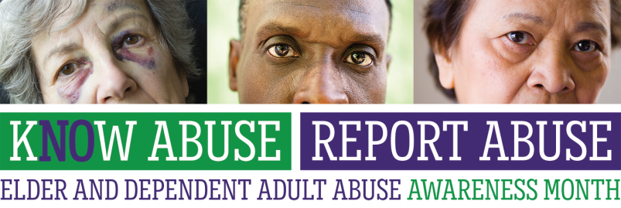

**(AAA LOGO)**

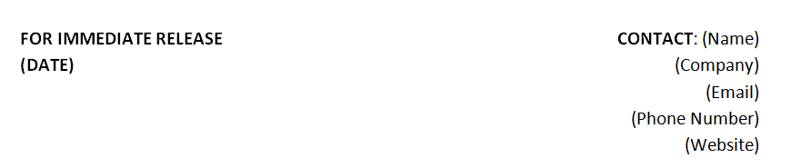

**SAMPLE TITLE 1: <AAA/Organization> Urges You to “Know Abuse, Report Abuse”**

Campaign designed to help raise awareness of elder   
and dependent adult abuse

**SAMPLE TITLE 2: <AAA/Organization> Commemorates Elder and Dependent Adult Abuse Awareness Month this June**

Effort encourages increased awareness and reporting of elder and dependent adult abuse in our communities

**(City), Calif., (Date) -** In California, as many as 50,000 cases of elder and dependent adult abuse go unreported every month. To help increase reporting, <AAA/Organization> is teaming up with older adult advocates from throughout the state to educate our communities about elder and dependent adult abuse during the month-long K**NO**W ABUSE REPORT ABUSE campaign in June.

Elder and dependent adult abuse takes many forms, some more obvious than others. Physical, mental, sexual, and financial abuse, as well as neglect and self-neglect are recognized in state law as forms of elder and dependent adult abuse. Reports for all types of elder and dependent adult abuse are on the rise. Here in <COUNTY/CITY/LOCATION>, abuse <provide a local stat>.

“We know that for every reported case of elder or dependent adult abuse, as many as four go unreported. That’s hundreds of thousands of people across the state who are not getting the help they need”, noted <NAME, POSITION>.

“It’s up to us as members of the community to Know Abuse, Report Abuse – to recognize when our older adults and those over 18 who are vulnerable are victims of abuse and then take that crucial next step to report it to the local Adult Protective Services agency or for those in long-term care facilities, the Long Term Care Ombudsman’s office,” said <NAME, POSITION>.

There are a number of indicators that may point to abuse, including:

* Lack of adequate food, water and other amenities
* Dirty clothing and changes in personal hygiene
* Bruises, black eyes, broken bones
* Bloody, ripped or stained clothing, sheets
* Harassment, coercion, intimidation, humiliation
* Unexplained purchases by the primary caregiver

<NAME OF COUNTY> County (or the name of the regional AAA) has a 24-hour hotline for reporting abuse of older adults and disabled adults who may be physically or financially abused, neglected, or exploited. The local APS number is (XXX) XXX-XXXX. To report suspected abuse of an elder in a nursing home, residential care facility for the elderly, or assisted living facility, contact the State CRISISline number: 1-800-231-4024 or your local Long Term Care Ombudsman Program: (XXX) XXX-XXXX.

###

**<Name of AAA/Organization>**

<About your org>

**Elder and Dependent Adult Abuse Awareness PSAs**

|  |  |
| --- | --- |
| WHAT | Draft Public Service Announcements |
| PURPOSE | **To provide a variety of sample PSAs that can be tailored locally for radio use during the month of June** |

**PSA 1**

For every case of elder abuse reported, an estimated four cases go unreported. It’s up to us as caring neighbors and community members to be on the lookout for the older adults and younger vulnerable adults who are incapable of protecting themselves. Some members of the community, including care custodians, healthcare providers and many government employees are required by law to report abuse; however, everyone should be encouraged to report whether they are mandated or not. Unexplained changes in behavior, bruises, or lack of clean clothing can suggest abuse. Be in the know. K**no**w Abuse. Report Abuse. If you suspect a loved one or neighbor of being a victim of abuse, please call <NAME OF COUNTY’s> Adult Protective Services at ###-####. Again, the number is ###-####.

**PSA 2**

As an APS worker from <COUNTY> I protect older adults and those over 18 who are vulnerable on a daily basis, but I know that sometimes elder and dependent adult abuse isn’t obvious. We need you and all members of the community to help us identify and report potential victims of abuse, neglect, and exploitation. Signs of potential abuse include: unexplained changes in behavior or personal hygiene, or lack of basic necessities. Know abuse, report abuse by calling Adult Protective Services at ###-####, day or night. Again, the number is ###-####.

**PSA 3**

June is Elder and Dependent Adult Abuse Awareness Month. As the number of older adults continues to grow, we may see more people become vulnerable to financial abuse, physical abuse, or neglect. It’s up to you, to us, to keep a watchful eye on our neighbors and community members. Please call Adult Protective Services at ###-#### if you suspect that an older or dependent adult needs help. Call ###-####, day or night.

**PSA 4**

Hi, I’m <Name> of the <Name of Organization/AAA>. Reaching the golden years should be a time to enjoy life with family and friends and not a time of fear or worry. Financial exploitation – by a family member, caregiver, or scammer – is a common way that our older family members are taken advantage of: unpaid bills, new credit cards or unusual purchases by a caregiver might be signs of financial abuse. If you believe you or a loved one might be a victim, please call ###-####. Once again, the number is ###-####, call anytime day or night.