CSEC: Youth Prevention & Intervention Training Curriculum
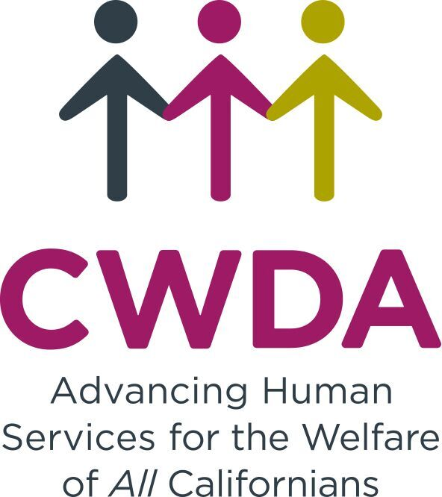
Rev. 4/16/16

PREVENTION TRAININGS:

Los Angeles County Probation Department

The Los Angeles County Probation Department developed “Word on the Street: Educating and Empowering Young Women and Girls,” an interactive CSEC prevention curriculum designed for a group of 3-12 female youth between the ages of 14 – 18. The training sessions are designed for foster youth (both child welfare and juvenile-justice youth), delivered by co-facilitators, covering sensitive material which can be a trigger for youth attendees. The curriculum can be delivered through 6 one-week sessions (lasting 90 minutes each), or in a one-day (5 hour) conference or abbreviated for youth in juvenile halls. The County provides a train-the-trainer model and has sessions in LA County or can arrange to provide T4T locally (CWDA suggests coordinating with your local Regional Training Academy).

Contact: Michelle Guymon, CSEC Program Manager, LA County Probation

Michelle.Guymon@probation.lacounty.gov or 661-236-5405

Justice Resource Institute

Preventing the Commercial Sexual Exploitation of Girls: A Training for Providers on Using the My Life My Choice Curriculum
This nationally renowned curriculum is a ten-session program created to develop and strengthen efforts to halt the disturbing wave of exploitation and trafficking in the United States. Created in 2002, the My Life My Choice Curriculum is used in schools, group homes, juvenile justice facilities, and community based agencies and is currently being utilized in over 20 states. We offer these trainings four times a year in Boston and throughout the United States, per request. Click here: to find out more information on their curriculum.

http://www.fightingexploitation.org/professional-training

Phone: 617-779-2179 or Email: mlmcinfo@jri.org

Sexual Exploitation of Children and Teens (SECT) Community Collaborative
The SECT Community Collaborative which is led by Sac City Unified School District coordinates CSEC youth trainings to deliver trainings with collaborative members (mainly Bridget's Dream and Another Choice Another Chance).

Contact: Cailey Bronny, (916) 643-7995 Cailey-Bronny@scusd.edu
http://www.sacramentosect.org/

iEmpathize
http://iempathize.org/
The program empowers youth and equips adults to preventatively recognize and respond to issues of exploitation. The Empower Youth Program for Teens is a tool that helps those already working with youth to facilitate prevention-focused conversations about empathy and exploitation in their schools and neighborhoods. Educators, parents, and youth service providers can utilize this five-part series of short films, activities, and discussion questions to empower teens 7th grade and up to successfully navigate the vulnerabilities in their lives in order to stay safe from exploitation. Facilitation for Jr. High age youth – mixed group boys/girls

Cost: $25.00 on-line version; $50.00 hard book version
Contact: 303-625-4074 or info@iEmpathize.org

Love Never Fails - Love Don’t Hurt - Curriculum
http://www.loveneverfailsus.com/
The Love Don’t Hurt program was developed to promote healthy relationships for middle and high school students. We believe that by doing this we will empower youth to detect and avoid sex trafficking. At the conclusion of the program students will be able to recognize the four types of abuse and how they might be experiencing these types in their own lives. They will also be empowered to prevent future abuse with help resources and awareness tools.
Each of the modules included in this program are directly aligned with Health Education Content Standards for California Public Schools.

Cost: Negotiated with the organization
Facilitation for Jr. High/High School – mixed group boys/girls

Kern Coalition Against Human Trafficking & Runaway Girl, Inc.
Mr. Gazley is the coordinator of Kern Coalition Against Human Trafficking and does anti human trafficking work in Kern, in the US, and internationally. Diana Cisneros is a survivor and trained by Runaway Girl, Inc., a company founded by Carissa Phelps, http://runawaygirl.com/ which has developed curriculum for prevention training. Both provide training throughout local communities (eg. schools, nonprofits, judges, etc.). They have a two hour prevention session designed for foster youth.

Cost: $35 per hour; Youth brochure also available
Phil Gazley, Coordinator, gazleys@hotmail.com, 303-261-2948
Diana Cisneros, Runaway Girl (local survivor), dcisneros132@gmail.com
http://kcaht.org/

Additional Training Offered by Runaway Girl, Inc.
- 8 hour DOJ/ODP approved awareness course for law enforcement. In this course we share instruction with law enforcement, community organizations, local experts and local survivor leaders. We were able to open up to community based orgs and service providers even though it is a law enforcement focused training.
- Human Trafficking (HT) “CPR” Community Protocol for Response (HT or CSEC specific)
  - 6 hour training
  - 3 hour community wide workshop
  - 1 hour A-B-C Presentations of Awareness, Belief and Capacity building
- HT “EMT” Empowerment Model Training
  - 12 hour training for service providers and front line professionals with extended or repeated contact with survivors and victims of all forms of human trafficking
- HT “MEDIC” Training
  - 24 hour (4 day course) this is a Train the Trainer model used by Learn 4 Life to reach over 700 educators and 30,000 students. Participants are now conducting community awareness trainings and presentations after attending this training. If you want to multiply the work done in your community to raise awareness and build training capacity around HT consider “HT MEDIC” for hands on training experience.
- CSEC Prevention for Foster Youth and Foster Alumni
  - 2 hour CSEC prevention workshop for youth. This exclusive RG workshop includes “Survivor Town” an experiential activity to engage and empower youth to access local resources.
For additional information contact Carissa Phelps, RunawayGirl.com at carissa@runawaygirl.org or work: (805) 265-3714 cell: (801) 850-3918
Break Free and 3Strands Global, Inc.
Break Free and 3Strands Global, Inc. is a joint effort to combat human trafficking based in the Sacramento area. They provide Break Free Education presented in venues including classrooms, school assemblies, and group homes. This is not a train-the-trainer model, but the training can be delivered anywhere in California. Training length is 60-90 minutes.

Contact: Ashlie Bryant, Executive Director, ashlie@runforcourage.org, (916) 221-8876
http://www.breakfree.org/education/

Project P.R.E.V.E.N.T
The Center for School Safety, School Climate, and Classroom Management (based in Atlanta, Georgia) has developed Project P.R.E.V.E.N.T (Promoting Respect, Enhancing Value, Establishing New Trust), a research-based, interactive curriculum created to promote the healthy growth and development of adolescent girls. Project P.R.E.V.E.N.T. provides girls with tools to enhance their personal strengths. The program promotes girls’ critical-thinking and decision-making skills, which may help keep them safe in vulnerable situations. Although Project P.R.E.V.E.N.T. was originally created as a pilot prevention program with middle school girls in an urban school district, the model encourages users to modify the curriculum to local needs.

Contact: Dr. Ann Kruger, ackruger@gsu.edu or 404-413-8482 (main line)
http://schoolsafety.education.gsu.edu/research/project-p-r-e-v-e-n-t/

Powerful Voices
In Seattle, Washington, Powerful Voices program targets female youth between 10 and 17 years of age to promote positive relationship skills and reduce vulnerability to intimate partner violence and CSEC.

http://www.powerfulvoices.org/curriculum/index.shtml
Contact: Jane Hinton, Executive Director, (206) 860-1026, janeh@powerfulvoices.org or info@powerfulvoices.org

INTERVENTION TRAININGS:

Girls Education and Mentoring Service
GEMS’ Victim, Survivor, LeaderTM (VSLTM) curriculum moves organizations past the CCIP “CSEC 101” curriculum and into specialized service provision with a survivor empowerment/leadership focus, which is at the heart of all of GEMS programming. The VSLTM curriculum is based on two foundational principles that shape and guide all of GEMS’ work: survivor leadership and Transformational Relationships, which are vital for effective youth development, particularly victims of CSEC.
http://www.gems-girls.org/get-trained/training-curriculum
Phone: (212) 926-8089
Sowers Education Group in collaboration with Runaway Girl, Inc.
sower (n.) \so-er\: one who spreads seeds for the purpose of growth. Our MISSION: 1) Prevent human trafficking & 2) Help youth navigate in a media-driven society

Ending The Game© is a 1st-of-its-kind “coercion resiliency” curriculum that reduces feelings of attachment to traffickers and/or a lifestyle characterized by commercial sexual exploitation, thereby reducing the rate of recidivism among sex trafficking survivors.
Ending The Game (ETG) is designed to educate and empower survivors of commercial sexual exploitation and trafficking by providing a structure and framework to uncover harmful psychological coercion (a.k.a. “The Game”) that victims may have been subjected to during or before their exploitation experience. By revealing a sequence of commonly-used, yet seldom-explained, mind control techniques used by traffickers, sexual abusers, media and other coercive agents, we aim to empower victims to acquire skills and end “The Game.”
WATCH THIS VIDEO PREVIEW: Real life survivors talk about how they ENDED “The Game” https://vimeo.com/115893519

Website: http://sowerseducationgroup.com/
Contact: office@sowerseducationgroup.com, Long Beach, CA, 323-577-5769

For questions on this document or to update this information please contact Diana Boyer, CWDA, (916) 443-1749 or dboyer@cwda.org

