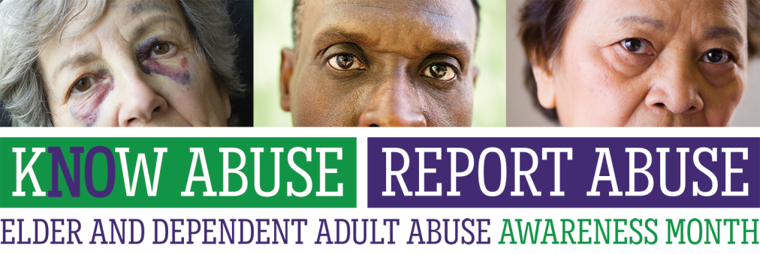

**Elder and Dependent Adult Abuse Awareness Month**

**Sample Social Media Content**

This is your Elder and Dependent Adult Abuse Awareness Month Social Media Content Guide. The purpose of the guide is to give you a strong foundation of content leading up to and during the month-long campaign this June.

**In this guide you will find:**

* ‘How-to’ guide for pinning Facebook and Twitter posts
* Sample Tweets to elected officials
* Posts announcing the Elder and Dependent Adult Abuse Awareness Campaign
* Posts for events submitted by AAAs and partner organizations
* General campaign Facebook and Twitter posts
* Twitter handles: CA State Legislature and CA Congressional Delegation

**Our campaign hashtag is:**

**#kNOwAbuseReportAbuse**

**Other campaign hashtags include:**

**#StopElderAbuse ◊ #AreaAgencyOnAging**

Since one of our primary campaign goals is to increase reporting for elder and dependent adult abuse, we want to make it as easy as possible for people to report. To help with this, we suggest you ‘pin’ a Facebook post and Twitter tweet to the top of your organization’s feed, including the campaign logo and your local reporting hotline number(s).



**How to Pin a Tweet on Twitter**

Once logged into your Twitter account, click the ‘tweet’ icon in the upper right corner of your screen, and then compose your tweet



Once you’ve tweeted, you then click on the tweet you’d like to pin to your profile. From there, click the three dots in the lower right corner of the tweet.



Then click ‘pin to your profile page’

You will then have a pinned tweet to your Twitter profile page! This tweet will appear at the top of your profile to all your followers and those who visit Twitter profile.





**How to Pin a Post on Facebook**

Once logged in to Facebook, compose your post in the white box at the top of your screen and click ‘post’



Once your post has been posted to your profile page, then click the small arrow in the top right corner of your post.

**Then click ‘Pin to Top’**

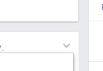

Your post is now pinned to the top of your profile page and will show the symbol below!

**SAMPLE TWEETS TO ELECTED OFFICIALS**

* [.@Rendon63rdAD](mailto:.@Rendon63rdAD) - Every yr an est. 5 mil (1/10) older Americans are victims of elder abuse, neglect, or exploitation. #kNOwAbuseReportAbuse
* [.@SenatorDeLeon](mailto:.@SenatorDeLeon) As the older population in America continues to grow, it is essential to recognize and report #ElderAbuse.
* [.@IanCalderon](mailto:.@IanCalderon) Who is at risk for #ElderAbuse? Elder abuse affects seniors across all socio-economic groups, cultures, and races.
* [.@mikegatto](mailto:.@mikegatto) Let your constituents know where they can report suspected #elder & dependent adult abuse. <http://bit.ly/1idrXgv>
* [.@BethGaines_](mailto:.@BethGaines_) Experts believe for every case of elder abuse or neglect reported, as many as 4 go unreported. #kNOwAbuseReportAbuse

**A few tips:**

* To avoid having everyone post the same content on the same days, please make sure you randomize the non-date specific content in the bank below
* Don’t forget to retweet and share posts from partner orgs and other AAAs
* When reaching out to elected officials, thought leaders, and other organizations on Twitter, make sure to place a period ‘.’ In front of the Twitter handle (.@)

|  |  |  |
| --- | --- | --- |
| **POSTS ANNOUNCING THE CAMPAIGN** | | |
| **Facebook** | **Twitter** | **Photo** |
| Elder and Dependent Adult Abuse Awareness Month is right around the corner! Stay in the kNOw by ‘liking’ us on Facebook and following us on Twitter for the latest info and to learn about events in your county. | Elder & Dependent Adult Abuse Awareness Month is right around the corner! For the latest in your county, follow us! #kNOwAbuseReportAbuse |  |
| This June, agencies and organizations from across the state will work together to raise awareness for elder and dependent adult abuse. Join us as we educate Californians about the various types of abuse and where to report suspected abuse. #kNOwAbuseReportAbuse | Join organizations around the state this June in our quest to #kNOwAbuseReportAbuse. |  |
| June is Elder and Dependent Adult Abuse Awareness Month. Report suspected abuse in (name of county here) by calling INSERT HOTLINE #kNOwAbuseReportAbuse | June is Elder and Dependent Adult Abuse Awareness Month. Call HOTLINE # to report abuse in (COUNTY NAME) #kNOwAbuseReportAbuse |  |
| Join us this June to raise awareness for elder and dependent adult abuse. #kNOwAbuseReportAbuse | Join us this June to raise awareness for elder and dependent adult abuse. #kNOwAbuseReportAbuse |  |
| Suspect abuse? Report it. (INSERT HOTLINE #) #kNOwAbuseReportAbuse | Suspect abuse? Report it. (INSERT HOTLINE #) #kNOwAbuseReportAbuse |  |
| Need to report elder or dependent adult abuse in another county? Find the complete list of county contact information here. #kNOwAbuseReportAbuse  <http://bit.ly/1idrXgv> | Need to report elder or dependent adult abuse in another county? Complete list of county contact info here. #kNOwAbuseReportAbuse  <http://bit.ly/1idrXgv> | **Elder Abuse Month 2016 Logo** |
| Worried about a loved one in a long-term care or residential care facility? There’s a 24-hour crisis line you can call to report suspected abuse: 1-800-231-4024 #kNOwAbuseReportAbuse | The CRISISline is available 24/7 to report suspected abuse of those living in a long term care facilities. 1-800-231-4024 #kNOwAbuseReportAbuse |  |
| **POSTS FOR EVENTS SUBMITTED BY AAAs and PARTNER ORGANIZATIONS** | | |
| **Facebook** | **Twitter** | **Photo** |
| Save the Date! For those of you in SD region, join us for our Age Well San Diego 2016 summit with keynote speaker Dick Van Dyke! | We hope to see you there: |  |
| The California Elder Justice Coalition, San Francisco's Department of Aging and Adult Services, and the @InstituteOnAging will be co-hosting an event on June 8th in observance of Elder Abuse and Dependent Adult Abuse Awareness Month and World Elder Abuse Awareness Day. We hope you can join us! <http://www.elderjusticecal.org/> | Join us! |  |
| Join us on June 10 for the Central Coast Elder Justice Summit titled, ‘Out of the Shadows: Bringing Issues of Elder and Dependent Adult Abuse to Light.’ For more information and ticket prices, please visit: <http://bit.ly/1rrq9K9> | Join us June 10 for the Central Coast Elder Justice Summit! For more information and tickets: <http://bit.ly/1rrq9K9> #kNOwAbuseReportAbuse |  |
| We hope you can join us on June 24 for Newman’s 15th Annual Senior Information Day! This year we are celebrating our heritage, so come dressed like the nationality you want to represent. For questions about the event or booth participation contact Debi Cardona at [debicardona@gmail.com](mailto:debicardona@gmail.com) or 209-534-9939. | Join us for Newman’s 15th Annual Sr Info Day! Questions? Email Debi [debicardona@gmail.com](mailto:debicardona@gmail.com). #kNOwAbuseReportAbuse | cid:image001.jpg@01D1A478.EC1F4C80 |
| Join us on June 15 for the 19th Annual Kern County Elder Abuse Prevention Conference presented by the Kern County Aging & Adult Services – APS, Kern County Commission on Aging, Domestic Violence Advisory Council and Kern County Mental Health Department. | Join us on June 15 for the 19th Annual #KernCounty Elder Abuse Prevention Conference! #kNOwAbuseReportAbuse |  |
| Free event for seniors and families! Join us on June 14 at the Petaluma Community Center for this educational panel on financial fraud and medical safety. #kNOwAbuseReportAbuse | Join us on 6/14 for a free event, educating seniors & families on elder abuse awareness & prevention! #kNOwAbuseReportAbuse | cid:image003.jpg@01D1A478.EC1F4C80 |
| **GENERAL CAMPAIGN POSTS and RESOURCES** | | |
| **Facebook** | **Twitter** | **Photo** |
| Older adults are a major target for financial scams. The San Diego County Health and Human Services Agency, @LiveWellSan DiegoNorthCounty and @SanDiego DistrictAttorney’s Office teamed up to provide this Stop Scams Toolkit. <http://bit.ly/1RKvhSa> | Older adults are a target for financial scams – this toolkit can help #elders avoid becoming a victim. <http://bit.ly/1RKvhSa> |  |
| Aging and dependent adults are susceptible to self-neglect. The San Diego County HHSA provides insight on what you can do. #kNOwAbuseReportAbuse <http://bit.ly/235htXv> | Aging & dependent adults are susceptible to self-neglect. Here are tips on what you can do to #kNOwAbuseReportAbuse <http://bit.ly/235htXv> | **Elder Abuse Month 2016 Logo**  --OR-- |
| June 15 is World Elder Abuse Awareness Day. Wear purple to promote awareness and show your support. #kNOwAbuseReportAbuse | #WorldElderAbuseAwarenessDay is June 15th. Wear purple to promote awareness and show your support. #kNOwAbuseReportAbuse |  |
| If you suspect abuse, report it! You don’t need to prove that abuse is occurring; it’s up to the professionals to investigate. <http://bit.ly/1idrXgv> | Suspect abuse? Report it! You don’t need to prove that abuse is occurring; it’s up to the professionals to investigate. #kNOwAbuseReportAbuse |  |
| What can you do to help elder and dependent adults? Keep in touch regularly with older family members, neighbors, and friends. | What can you do to help #elder and #dependent adults? Keep in touch regularly with older family members, neighbors, and friends. |  |
| Who is at risk for elder abuse? Elder abuse affects seniors across all socio-economic groups, cultures, and races. <http://bit.ly/1idrXgv> | Who’s at risk for #ElderAbuse? Elder abuse affects seniors across all socio-economic groups, cultures, & races. #kNOwAbuseReportAbuse |  |
| As the number of Americans 65 and older increases, it is essential to be on the lookout for signs of abuse. #kNOwAbuseReportAbuse <http://bit.ly/1idrXgv> | As the older population in America continues to grow, it is essential to be aware of the signs and report #ElderAbuse. |  |
| Spot the red flag. Know the signs of elder and dependent adult abuse and report mistreatment today. #kNOwAbuseReportAbuse <http://bit.ly/1UyozCb> | Spot the red flag & report mistreatment of elder & dependent adults. #kNOwAbuseReportAbuse <http://bit.ly/1UyozCb> |  |
| Concerned about a loved one in a long-term or residential care facility? Learn more about how the California Long-Term Care Ombudsman Program can help resolve issues and ensure elders get the care they need. <http://bit.ly/1M7zDnj> | CA has a resource that helps resolve issues in long-term care facilities to ensure #elders get the care they need <http://bit.ly/1M7zDnj> |  |
| Did you know? #kNOwAbuseReportAbuse | DYK? #kNOwAbuseReportAbuse |  |
| June is Elder and Dependent Adult Abuse Awareness Month. #kNOwAbuseReportAbuse | June is Elder and Dependent Adult Abuse Awareness Month. #kNOwAbuseReportAbuse | R:\ACE\Client Folders\CA Area Agencies on Aging\Toolkit Docs\Elder Abuse Month 2016 Logo.jpg |
| What area are you in? If you are looking for local resources for aging adults, look no further. Click the link to be directed to individual Agency websites. <http://bit.ly/22dq3RI> | Looking for a #AreaAgencyonAging’s website? Click the link to find the AAA near you: <http://bit.ly/22dq3RI> |  |
| Dementia and elder abuse. These slides will go over some new terms, new concepts and new insights. #kNOwAbuseReportAbuse <http://bit.ly/1Va6aMe> | #Dementia and #elderabuse. These slides will go over some new terms, new concepts and new insights. <http://bit.ly/1Va6aMe> #kNOwAbuseReportAbuse |  |
| Do you know what the ‘Grandparent Scam’ is? It’s a scam that targets the elderly in an attempt to steal large sums of money through a wire transfer. | #DYK what the ‘Grandparent Scam’ is? It’s a scam that targets the elderly in an attempt to steal large sums of $ through a wire transfer. |  |
| The ‘Grandparent Scam.’ What you need to know. #kNOwAbuseReportAbuse | The ‘Grandparent Scam.’ What you need to know. |  |
| How social media can help stamp out ageism. <http://huff.to/1Tpd7Z1> #kNOwAbuseReportAbuse | How social media can help stamp out ageism. <http://huff.to/1Tpd7Z1> #kNOwAbuseReportAbuse |  |
| This type of elder abuse is unfortunately on the rise. Help us build awareness. #kNOwAbuseReportAbuse <http://huff.to/1JgLk9N> | This type of elder abuse is unfortunately on the rise. Help us build awareness. #kNOwAbuseReportAbuse <http://huff.to/1JgLk9N> |  |
| What prompts elder abuse? A new study looked into criminal case files to uncover common triggers. <http://bit.ly/1YMmO7k> #kNOwAbuseReportAbuse | What prompts elder abuse? A new study looked into criminal case files to uncover common triggers. <http://bit.ly/1YMmO7k> #kNOwAbuseReportAbuse |  |
| An increasing number of banks and credit unions are implementing fraud-prevention initiatives to prepare for the onslaught of aging Americans expected to develop Alzheimer’s disease. #kNOwAbuseReportAbuse <http://onforb.es/23Mxwx1> | What banks are doing to halt elder abuse. #kNOwAbuseReportAbuse <http://onforb.es/23Mxwx1> |  |
| Did you know: 10,000 people will be turning 65 every day for the next decade? <http://bit.ly/1idrXgv> #kNOwAbuseReportAbuse | DYK: 10,000 people will be turning 65 every day for the next decade? <http://bit.ly/1idrXgv> #kNOwAbuseReportAbuse | http://ecx.images-amazon.com/images/I/71%2Bm%2Byr9QZL._SL1280_.jpg |
| Financial abuse of the elderly. Sometimes unnoticed, always predatory. #kNOwAbuseReportAbuse <http://nyti.ms/1NEdJ66> | Financial abuse of the elderly. Sometimes unnoticed, always predatory. #kNOwAbuseReportAbuse <http://nyti.ms/1NEdJ66> |  |
| With over 50 million Americans aged 62 and older, older adults are prime targets for financial exploitation both by persons they know and trust and by strangers. Check out this “Money Smart” guide by the @ConsumerFinancialProtectionBureau and the Federal Deposit Insurance Corporation. #kNOwAbuseReportAbuse <http://1.usa.gov/1jrCfr7> | Check out this “Money Smart for Older Adults” guide. <http://1.usa.gov/1jrCfr7> #kNOwAbuseReportAbuse |  |
| Negative stereotypes about getting older can become a self-fulfilling prophecy. How to improve your mind-set—and well-being. #kNOwAbuseReportAbuse <http://on.wsj.com/1GO5q4l> | Neg. stereotypes about getting older can be a self-fulfilling prophecy. How to improve ur mind-set & well-being. <http://on.wsj.com/1GO5q4l> | If we see aging in terms of opportunity and growth, our bodies respond in kind. |
| How to detect elder abuse. Many people don't realize how common the problem is. #kNOwAbuseReportAbuse <http://bit.ly/1WIHQkp> | How to detect Elder Abuse. Many people don't realize how common the problem is. #kNOwAbuseReportAbuse <http://bit.ly/1WIHQkp> |  |
| #kNOwAbuseReportAbuse | #kNOwAbuseReportAbuse |  |

**Image Bank: campaign supporters/sponsors**

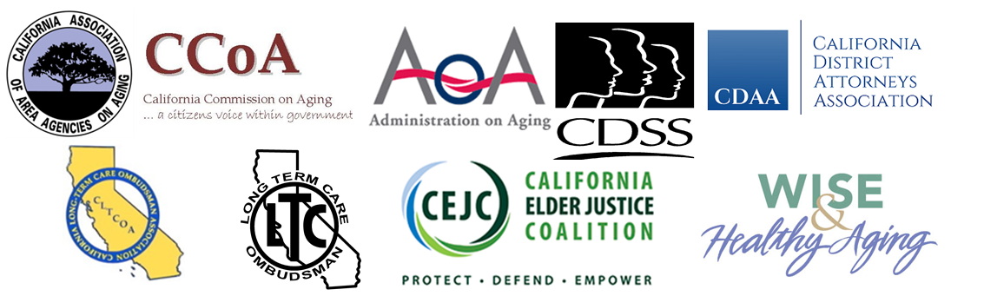

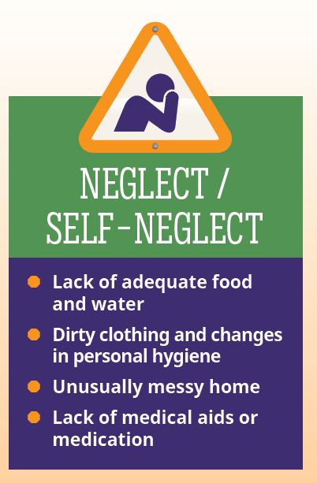 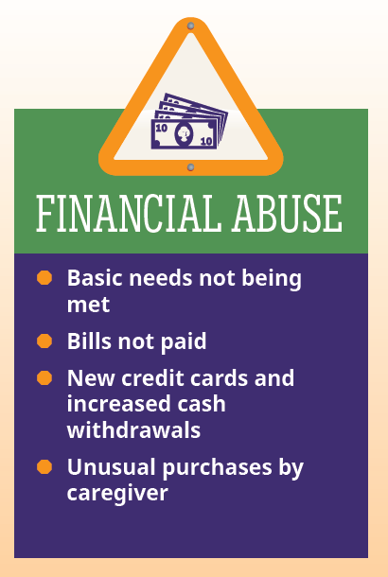 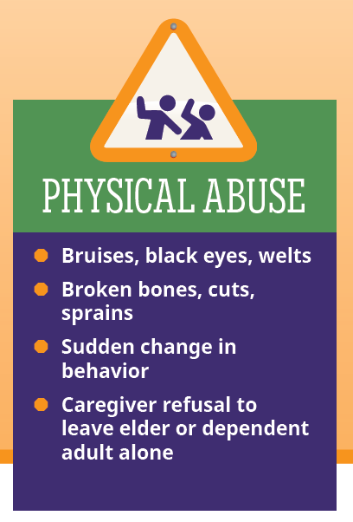 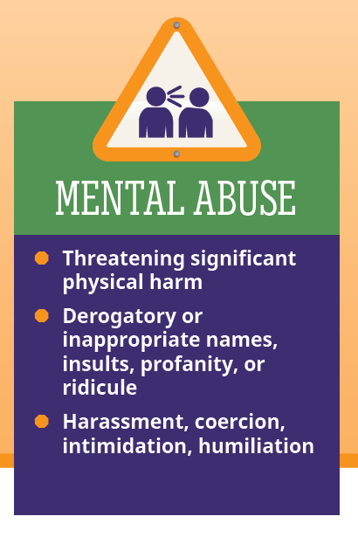 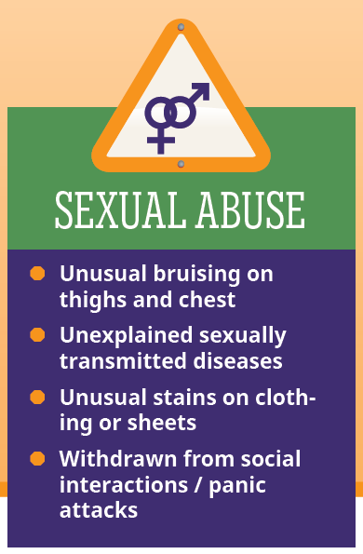

|  |  |  |  |  |
| --- | --- | --- | --- | --- |
| CA Legislators – Twitter Handles | | | | |
| Name | **Party** | **Branch** | **District** | **Twitter Handle** |
| Katcho Achadjian | R | State Assembly | District: 35 | .@KatchoAchadjian |
| Luis Alejo | D | State Assembly | District: 30 | [.@AsmLuisAlejo](mailto:.@AsmLuisAlejo) |
| Ben Allen | D | State Senate | District: 26 | [.@BenforSenate](mailto:.@BenforSenate) |
| Travis Allen | R | State Assembly | District: 72 | [.@JoinTravisAllen](mailto:.@JoinTravisAllen) |
| Joel Anderson | R | State Senate | District: 38 | [.@JoelAndersonCA](mailto:.@JoelAndersonCA) |
| Toni G. Atkins | D | State Assembly | District: 78 | [.@toniatkins](mailto:.@toniatkins) |
| Catharine Baker | R | State Assembly | District: 16 | [.@Baker4Assembly](mailto:.@Baker4Assembly) |
| Patricia Bates | R | State Senate | District: 36 | [.@SenatorPatBates](mailto:.@SenatorPatBates) |
| Jim Beall | D | State Senate | District: 15 | [.@Jimbealljr](mailto:.@Jimbealljr) |
| Tom Berryhill | R | State Senate | District: 08 | [.@TomBerryhill](mailto:.@TomBerryhill) |
| Frank Bigelow | R | State Assembly | District: 05 | [.@FrankBigelowCA](mailto:.@FrankBigelowCA) |
| Marty Block | D | State Senate | District: 39 | [.@MartyBlock39](mailto:.@MartyBlock39) |
| Richard H. Bloom | D | State Assembly | District: 50 | [.@RichardBloom](mailto:.@RichardBloom) |
| Susan Bonilla | D | State Assembly | District: 14 | [.@ASMSusanBonilla](mailto:.@ASMSusanBonilla) |
| Rob Bonta | D | State Assembly | District: 18 | [.@RobBonta](mailto:.@RobBonta) |
| William Brough | R | State Assembly | District: 73 | [.@bill_brough](mailto:.@bill_brough) |
| Cheryl Brown | D | State Assembly | District: 47 | [.@AsmCherylBrown](mailto:.@AsmCherylBrown) |
| Autumn Burke | D | State Assembly | District: 62 | [.@autumnrburke](mailto:.@autumnrburke) |
| Ian C. Calderon | D | State Assembly | District: 57 | .@IanAD57 |
| Nora Campos | D | State Assembly | District: 27 | [.@NoraCamposCA](mailto:.@NoraCamposCA) |
| Anthony J. Cannella | R | State Senate | District: 12 | [.@AnthonyCannella](mailto:.@AnthonyCannella) |
| Ling-Ling Chang | R | State Assembly | District: 55 | [.@LTwoC](mailto:.@LTwoC) |
| Ed Chau | D | State Assembly | District: 49 | [.@EdChau49](mailto:.@EdChau49) |
| Rocky Chávez | R | State Assembly | District: 76 | [.@AsmRocky](mailto:.@AsmRocky) |
| David Chiu | D | State Assembly | District: 17 | [.@DavidChiu](mailto:.@DavidChiu) |
| Kansen Chu | D | State Assembly | District: 25 | [.@kansenchu](mailto:.@kansenchu) |
| Ken Cooley | D | State Assembly | District: 08 | [.@KenCooley](mailto:.@KenCooley) |
| Jim Cooper | D | State Assembly | District: 09 | [.@JimCooper2014](mailto:.@JimCooper2014) |
| Matt Dababneh | D | State Assembly | District: 45 | [.@MattDababneh](mailto:.@MattDababneh) |
| Brian Dahle | R | State Assembly | District: 01 | [.@BrianDahleCA](mailto:.@BrianDahleCA) |
| Tom F. Daly | D | State Assembly | District: 69 |  |
| Kevin de Leon | D | State Senate | District: 24 | [.@SenatorDeLeon](mailto:.@SenatorDeLeon) |
| Bill Dodd | D | State Assembly | District: 04 | [.@BillDoddCA](mailto:.@BillDoddCA) |
| Susan Talamantes Eggman | D | State Assembly | District: 13 | [.@SusanEggman](mailto:.@SusanEggman) |
| Jim L. Frazier Jr. | D | State Assembly | District: 11 |  |
| Jean Fuller | R | State Senate | District: 16 | [.@JeanFuller](mailto:.@JeanFuller) |
| Beth Gaines | R | State Assembly | District: 06 | [.@BethGaines_](mailto:.@BethGaines_) |
| Ted Gaines | R | State Senate | District: 01 | [.@SenatorGaines](mailto:.@SenatorGaines) |
| Cathleen Galgiani | D | State Senate | District: 05 | [.@SenatorGalgiani](mailto:.@SenatorGalgiani) |
| James Gallagher | R | State Assembly | District: 03 | [.@J_GallagherAD3](mailto:.@J_GallagherAD3) |
| Cristina Garcia | D | State Assembly | District: 58 | [.@AsmGarcia](mailto:.@AsmGarcia) |
| Eduardo Garcia | D | State Assembly | District: 56 | [.@AsmEGarciaAD56](mailto:.@AsmEGarciaAD56) |
| Mike Gatto | D | State Assembly | District: 43 | [.@mikegatto](mailto:.@mikegatto) |
| Mike Gipson | D | State Assembly | District: 64 | [.@mgipson2014](mailto:.@mgipson2014) |
| Steven M. Glazer | D | State Senate | District: 07 |  |
| Jimmy Gomez | D | State Assembly | District: 51 | [.@JimmyGomezCA](mailto:.@JimmyGomezCA) |
| Lorena Gonzalez | D | State Assembly | District: 80 | [.@LorenaSGonzalez](mailto:.@LorenaSGonzalez) |
| Richard S. Gordon | D | State Assembly | District: 24 |  |
| Adam Gray | D | State Assembly | District: 21 | [.@GrayForAssembly](mailto:.@GrayForAssembly) |
| Shannon L. Grove | R | State Assembly | District: 34 | [.@shannongrove](mailto:.@shannongrove) |
| David Hadley | R | State Assembly | District: 66 | [.@DavidHadleyCA](mailto:.@DavidHadleyCA) |
| Isadore Hall III | D | State Senate | District: 35 |  |
| Loni Hancock | D | State Senate | District: 09 |  |
| Matthew Harper | R | State Assembly | District: 74 | [.@AsmHarper](mailto:.@AsmHarper) |
| Ed Hernandez O.D. | D | State Senate | District: 22 | [.@dredhernandez](mailto:.@dredhernandez) |
| Roger Hernández | D | State Assembly | District: 48 | [.@Roger_Hernandez](mailto:.@Roger_Hernandez) |
| Bob Hertzberg | D | State Senate | District: 18 | [.@hertzieLA](mailto:.@hertzieLA) |
| Jerry Hill | D | State Senate | District: 13 |  |
| Chris Holden | D | State Assembly | District: 41 | [.@ChrisHoldenNews](mailto:.@ChrisHoldenNews) |
| Ben Hueso | D | State Senate | District: 40 |  |
| Bob Huff | R | State Senate | District: 29 | [.@bobhuff99](mailto:.@bobhuff99) |
| Jacqui Irwin | D | State Assembly | District: 44 | [.@jacquiirwin](mailto:.@jacquiirwin) |
| Hannah-Beth Jackson | D | State Senate | District: 19 | [.@SenHannahBeth](mailto:.@SenHannahBeth) |
| Brian W. Jones | R | State Assembly | District: 71 | [.@AsmBrianJones](mailto:.@AsmBrianJones) |
| Reginald Byron Jones-Sawyer | D | State Assembly | District: 59 | [.@JonesSawyer](mailto:.@JonesSawyer) |
| Young Kim | R | State Assembly | District: 65 | [.@YKAssembly](mailto:.@YKAssembly) |
| Tom Lackey | R | State Assembly | District: 36 | [.@TomLackey36](mailto:.@TomLackey36) |
| Ricardo Lara | D | State Senate | District: 33 | [.@SenRicardoLara](mailto:.@SenRicardoLara) |
| Mark Leno | D | State Senate | District: 11 | [.@MarkLeno](mailto:.@MarkLeno) |
| Marc B. Levine | D | State Assembly | District: 10 | [.@MarcLevine](mailto:.@MarcLevine) |
| Connie Leyva | D | State Senate | District: 20 | [.@ConnieMLeyva](mailto:.@ConnieMLeyva) |
| Eric F. Linder | R | State Assembly | District: 60 | [.@EricLinder](mailto:.@EricLinder) |
| Carol Liu | D | State Senate | District: 25 | [.@SenatorCarolLiu](mailto:.@SenatorCarolLiu) |
| Patty Lopez | D | State Assembly | District: 39 | [.@PattyLopez_D_39](mailto:.@PattyLopez_D_39) |
| Evan Low | D | State Assembly | District: 28 | [.@Evan_Low](mailto:.@Evan_Low) |
| Brian Maienschein | R | State Assembly | District: 77 | [.@BMaienschein](mailto:.@BMaienschein) |
| Devon Mathis | R | State Assembly | District: 26 | [.@AD26Mathis](mailto:.@AD26Mathis) |
| Chad Mayes | R | State Assembly | District: 42 | [.@ChadMayesCA](mailto:.@ChadMayesCA) |
| Kevin McCarty | D | State Assembly | District: 07 | [.@KMcCartyAD7](mailto:.@KMcCartyAD7) |
| Mike McGuire | D | State Senate | District: 02 | [.@ilike_mike](mailto:.@ilike_mike) |
| Jose Medina | D | State Assembly | District: 61 | [.@AsmJoseMedina](mailto:.@AsmJoseMedina) |
| Melissa Melendez | R | State Assembly | District: 67 | [.@asmMelendez](mailto:.@asmMelendez) |
| Tony Mendoza | D | State Senate | District: 32 | [.@MrTonyMendoza](mailto:.@MrTonyMendoza) |
| Holly J. Mitchell | D | State Senate | District: 30 | [.@HollyJMitchell](mailto:.@HollyJMitchell) |
| William W. Monning | D | State Senate | District: 17 | [.@billmonning](mailto:.@billmonning) |
| John Moorlach | R | State Senate | District: 37 | [.@SenatorMoorlach](mailto:.@SenatorMoorlach) |
| Mike L. Morrell | R | State Senate | District: 23 | [.@MikeMorrellGOP](mailto:.@MikeMorrellGOP) |
| Kevin Mullin | D | State Assembly | District: 22 | [.@kevinmullin](mailto:.@kevinmullin) |
| Adrin Nazarian | D | State Assembly | District: 46 | [.@adrinnazarian](mailto:.@adrinnazarian) |
| Janet Nguyen | R | State Senate | District: 34 | [.@JanetNguyenCA](mailto:.@JanetNguyenCA) |
| Jim W. Nielsen | R | State Senate | District: 04 |  |
| Jay Obernolte | R | State Assembly | District: 33 | [.@JayObernolte](mailto:.@JayObernolte) |
| Patrick O'Donnell | D | State Assembly | District: 70 | [.@AsmPatODonnell](mailto:.@AsmPatODonnell) |
| Kristin M. Olsen | R | State Assembly | District: 12 | [.@KristinOlsenCA](mailto:.@KristinOlsenCA) |
| Richard Pan M.D. | D | State Senate | District: 06 | [.@DrPanMD](mailto:.@DrPanMD) |
| Jim Patterson | R | State Assembly | District: 23 | [.@JimPatterson559](mailto:.@JimPatterson559) |
| Fran Pavley | D | State Senate | District: 27 | [.@SenatorPavley](mailto:.@SenatorPavley) |
| Bill Quirk | D | State Assembly | District: 20 | [.@AsmBillQuirk](mailto:.@AsmBillQuirk) |
| Anthony Rendon Ph.D. | D | State Assembly | District: 63 | [.@Rendon63rd](mailto:.@Rendon63rd) |
| Sebastian Ridley-Thomas | D | State Assembly | District: 54 | [.@sridleythomas](mailto:.@sridleythomas ) |
| Freddie Rodriguez | D | State Assembly | District: 52 | [.@AsmRodriguez52](mailto:.@AsmRodriguez52) |
| Richard D. Roth | D | State Senate | District: 31 | [.@GeneralRoth](mailto:.@GeneralRoth) |
| Sharon Runner | R | State Senate |  | [.@SharonRunner](mailto:.@SharonRunner) |
| Rudy Salas | D | State Assembly | District: 32 | [.@rudysalasjr](mailto:.@rudysalasjr) |
| Miguel Santiago | D | State Assembly | District: 53 | [.@SantiagoAD53](mailto:.@SantiagoAD53) |
| Marc Steinorth | R | State Assembly | District: 40 | [.@MarcSteinorth](mailto:.@MarcSteinorth) |
| Jeff Stone | R | State Senate | District: 28 | [.@SenJeffStone](mailto:.@SenJeffStone) |
| Mark Stone | D | State Assembly | District: 29 | [.@AsmMarkStone](mailto:.@AsmMarkStone) |
| Tony Thurmond | D | State Assembly | District: 15 | [.@TonyThurmond](mailto:.@TonyThurmond) |
| Philip Y. Ting | D | State Assembly | District: 19 | [.@PhilTing](mailto:.@PhilTing) |
| Andy Vidak | R | State Senate | District: 14 | [.@SenAndyVidak](mailto:.@SenAndyVidak) |
| Donald P. Wagner | R | State Assembly | District: 68 | [.@Donald_Wagner](mailto:.@Donald_Wagner) |
| Marie Waldron | R | State Assembly | District: 75 | [.@ConservtveWoman](mailto:.@ConservtveWoman) |
| Shirley N. Weber | D | State Assembly | District: 79 | [.@DrShirleyWeber](mailto:.@DrShirleyWeber) |
| Bob Wieckowski | D | State Senate | District: 10 | [.@BobWieckowskiCA](mailto:.@BobWieckowskiCA) |
| Scott T. Wilk | R | State Assembly | District: 38 | [.@ScottWilkCA](mailto:.@ScottWilkCA) |
| Das G. Williams | D | State Assembly | District: 37 | [.@DasWilliams](mailto:.@DasWilliams) |
| Lois Wolk | D | State Senate | District: 03 | [.@SenLoisWolk](mailto:.@SenLoisWolk) |
| Jim Wood | D | State Assembly | District: 02 | [.@JimWoodAD2](mailto:.@JimWoodAD2) |

|  |  |  |  |  |
| --- | --- | --- | --- | --- |
| CA Congressional Delegation - Twitter Handles | | | | |
| Name | **Party** | **Branch** | **District** | **Twitter Handle** |
| Pete Aguilar | D | U.S. House | District: 31 | .@RepPeteAguilar |
| Karen Bass | D | U.S. House | District: 37 | .@RepKarenBass |
| Xavier Becerra | D | U.S. House | District: 34 | .@RepBecerra |
| Ami Bera Dr. | D | U.S. House | District: 07 | .@RepBera |
| Barbara Levy Boxer | D | U.S. Senate |  | .@SenatorBoxer |
| Julia Brownley | D | U.S. House | District: 26 | .@JuliaBrownley26 |
| Ken Calvert | R | U.S. House | District: 42 | .@KenCalvert |
| Lois Capps | D | U.S. House | District: 24 | .@RepLoisCapps |
| Tony Cárdenas | D | U.S. House | District: 29 | .@RepCardenas |
| Judy Chu Dr. | D | U.S. House | District: 27 | .@RepJudyChu |
| Paul Cook | R | U.S. House | District: 08 | .@RepPaulCook |
| Jim Costa | D | U.S. House | District: 16 | .@RepJimCosta |
| Susan A. Davis | D | U.S. House | District: 53 | .@RepSusanDavis |
| Jeff Denham | R | U.S. House | District: 10 | .@RepJeffDenham |
| Mark DeSaulnier | D | U.S. House | District: 11 | .@RepDeSaulnier |
| Anna G. Eshoo | D | U.S. House | District: 18 | .@RepAnnaEshoo |
| Sam Farr | D | U.S. House | District: 20 | .@RepSamFarr |
| Dianne Feinstein | D | U.S. Senate |  | .@SenFeinstein |
| John Garamendi | D | U.S. House | District: 03 | .@RepGaramendi |
| Janice Hahn | D | U.S. House | District: 44 | ‎.@Rep_JaniceHahn |
| Mike Honda | D | U.S. House | District: 17 | .@RepMikeHonda |
| Jared Huffman | D | U.S. House | District: 02 | .@RepHuffman |
| Duncan D. Hunter | R | U.S. House | District: 50 | .@Rep_Hunter |
| Darrell Issa | R | U.S. House | District: 49 | .@DarrellIssa |
| Steve Knight | R | U.S. House | District: 25 | .@SteveKnight25 |
| Doug La Malfa | R | U.S. House | District: 01 | .@RepLaMalfa |
| Barbara Lee | D | U.S. House | District: 13 | .@RepBarbaraLee |
| Ted Lieu | D | U.S. House | District: 33 | .@RepTedLieu |
| Zoe Lofgren | D | U.S. House | District: 19 | .@RepZoeLofgren |
| Alan Lowenthal | D | U.S. House | District: 47 | .@RepLowenthal |
| Doris O. Matsui | D | U.S. House | District: 06 | .@DorisMatsui |
| Kevin McCarthy | R | U.S. House | District: 23 | .@GOPLeader |
| Tom McClintock | R | U.S. House | District: 04 | .@RepMcClintock |
| Jerry McNerney | D | U.S. House | District: 09 | .@RepMcNerney |
| Grace F. Napolitano | D | U.S. House | District: 32 | .@gracenapolitano |
| Devin Nunes | R | U.S. House | District: 22 | .@Rep_DevinNunes |
| Nancy Pelosi | D | U.S. House | District: 12 | .@NancyPelosi |
| Scott Peters | D | U.S. House | District: 52 | .@RepScottPeters |
| Dana Rohrabacher | R | U.S. House | District: 48 | .@DanaRohrabacher |
| Lucille Roybal-Allard | D | U.S. House | District: 40 | .@RepRoybalAllard |
| Ed Royce | R | U.S. House | District: 39 | .@RepEdRoyce |
| Raul Ruiz Dr. | D | U.S. House | District: 36 | .@CongressmanRuiz |
| Loretta Sanchez | D | U.S. House | District: 46 | .@LorettaSanchez |
| Linda Sánchez | D | U.S. House | District: 38 | .@RepLindaSanchez |
| Adam Schiff | D | U.S. House | District: 28 | .@RepAdamSchiff |
| Brad Sherman | D | U.S. House | District: 30 | .@BradSherman |
| Jackie Speier | D | U.S. House | District: 14 | .@RepSpeier |
| Eric Swalwell | D | U.S. House | District: 15 | .@RepSwalwell |
| Mark Takano | D | U.S. House | District: 41 | .@RepMarkTakano |
| Mike Thompson | D | U.S. House | District: 05 | .@RepThompson |
| Norma Torres | D | U.S. House | District: 35 | .@NormaJTorres |
| David G. Valadao | R | U.S. House | District: 21 | .@RepDavidValadao |
| Juan Vargas | D | U.S. House | District: 51 | .@RepJuanVargas |
| Mimi Walters | R | U.S. House | District: 45 | .@RepMimiWalters |
| Maxine Waters | D | U.S. House | District: 43 | .@MaxineWaters |